Name _______________________________________ Date ___________________________ Class _____

Waves and Sound Test

Matching – Answers may be used as often as necessary or not at all.
_____ 1. The position of a molecule before the energy of the wave moves it. A) music
_____ 2. Sounds that have a frequency of greater than 20,000 Hertz. B) electromagnetic
_____ 3. Sounds that are used deliberately in a regular pattern. C) hertz
_____ 4. Units used to measure a sound's intensity or loudness. D) subsonic
_____ 5. Type of wave that does not need a medium to travel through. E) diffraction
_____ 6. How high or low a sound seems to be. F) ultrasonic
_____ 7. Describes sounds with a frequency of less than 20 Hz. G) loudness
_____ 8. A hollow chamber of air that amplifies the sound of an instrument. H) resonator
_____ 9. The amount of energy a sound wave carries. I) pitch
_____ 10. Type of wave in which molecules are squeezed together and spread apart. J) dB
_____ 11. Sound that have too low a frequency to be heard by the human ear. K) rest position
_____ 12. How the human ear registers intensity. L) intensity
_____ 13. Sounds that have too high a frequency to be heard by the human ear. N) compressional

_____ 14. Type of interference in which the amplitudes subtract from each other. O) amplitude
_____ 15. When a wave bends to go around an object. P) medium
_____ 16. When sound waves from different instruments interfere with each other, Q) constructive
creating a wave with a new frequency. R) refraction
_____ 17. When vibrations at an object's natural frequency causes it to vibrate. S) frequency
_____ 18. The number of wavelengths that pass by in one second. T) sound quality
_____ 19. When a wave bends as it travels from the air to a glass lens. U) wave
_____ 20. The substance that a wave is traveling through. V) beats
_____ 21. A repeating disturbance or movement that carries energy. W) destructive
_____ 22. When a wave bounces off an object. X) resonance
_____ 23. Type of interference in which the amplitudes add together. Y) wavelength
_____ 24. Units used to measure frequency. Z) reflection
_____ _____ 25-26. This increases as the intensity of a wave increases. A) loudness
_____ 27. Causes the unique sound of each instrument because each instrument B) diffraction
vibrates at more than one frequency. C) Hz
Short Answer
28-29. Draw a diagram showing how sound waves coming a moving object are different from sound waves
from an object that is standing still.

True or False.
_____ 30. If a train whistle becomes higher pitched, the train is coming toward you.
______31. Infrasonic sounds are sounds that have a frequency of more than 120 dB.
_____ 32. When you turn up the volume on your radio, the amplitude and the frequency decrease.
_____ 33. The greater the intensity of a sound wave, the greater the amplitude of the wave.
_____ 34. A high note has a higher frequency and a shorter wavelength than a low note.

35-37. Label the 3 parts of this sound wave.

A
B
C

Label the parts of the ear below.
40
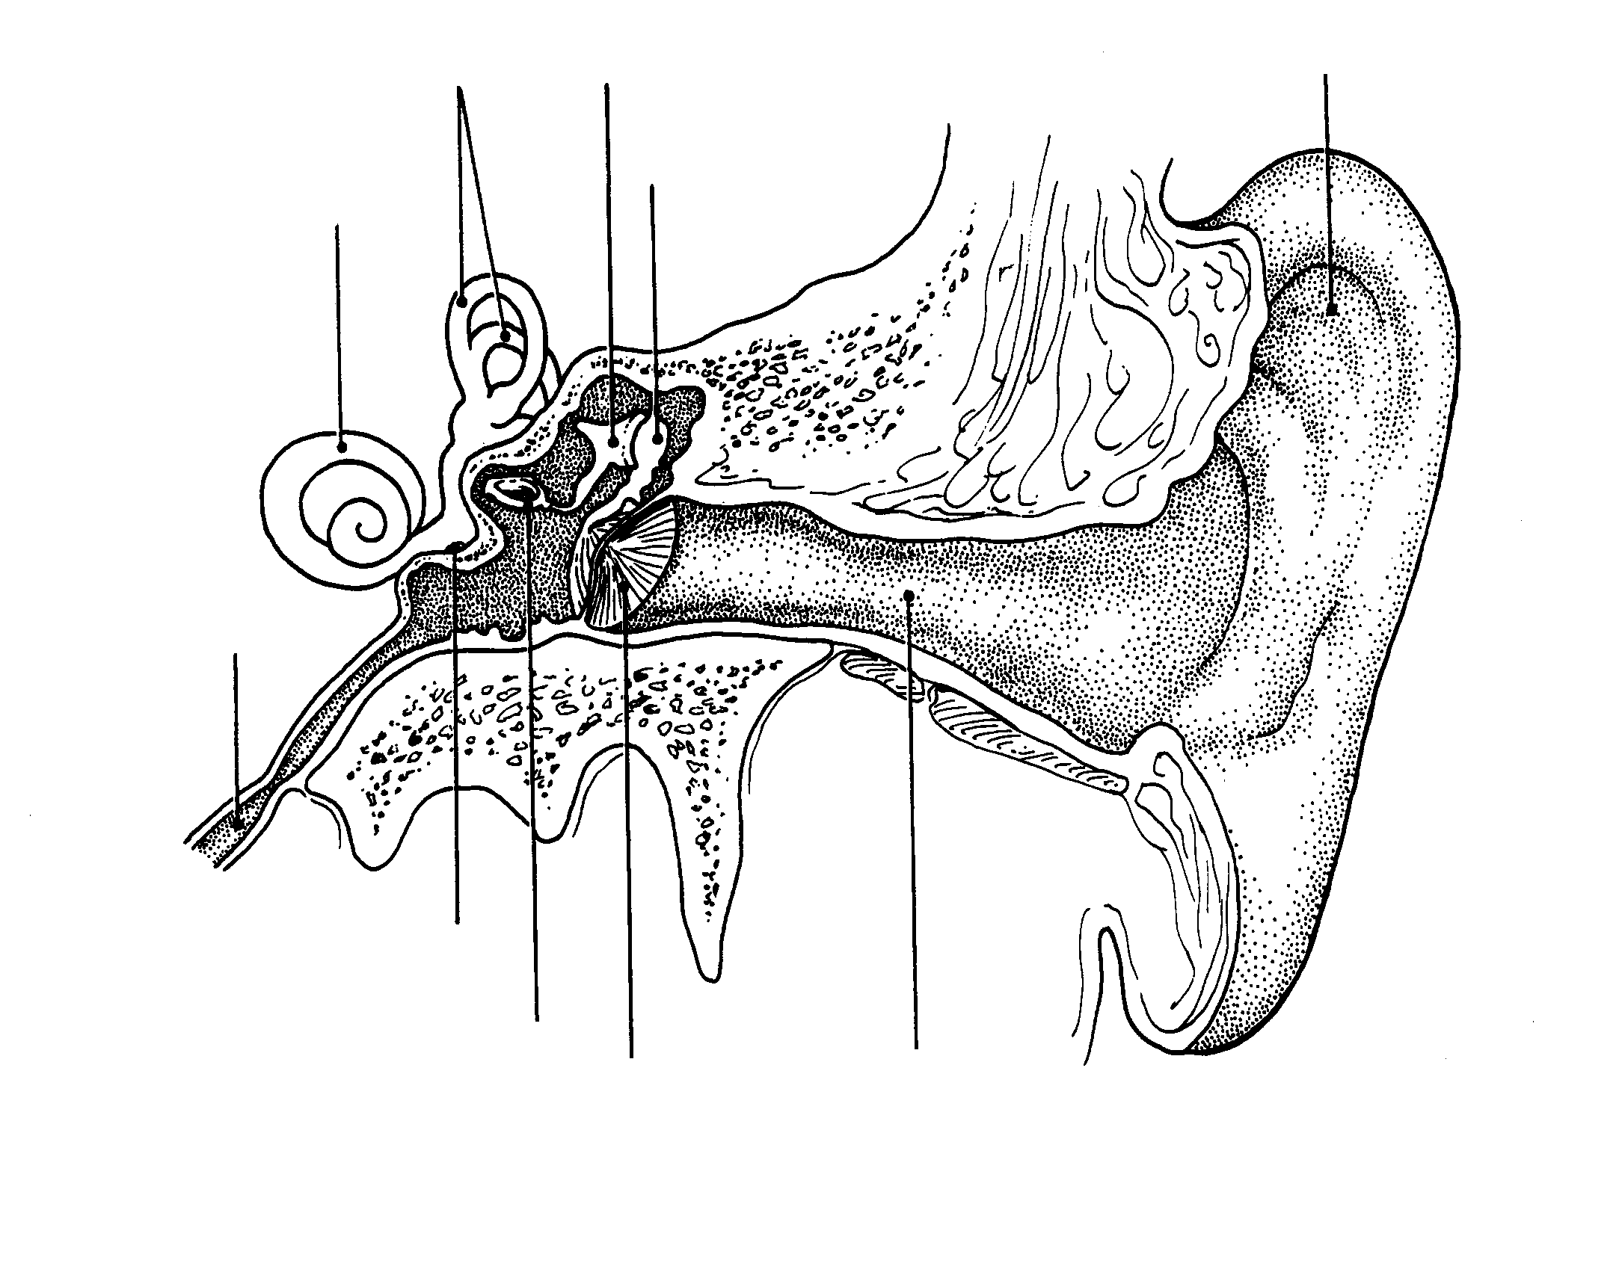
41
38
39
42

Put the name of the part of the ear that fits the description in the blank.
_____________________________ 43. The flap of the ear that catches sound waves out of the air.
_____________________________ 44.The bones in the middle ear that touches the eardrum.
_____________________________ 45. The third bone in the middle ear that touches the cochlea.
_____________________________ 46. Membrane in the ear that transfers the vibrations from the outer to
the inner ear.
_____________________________ 47. A coiled fluid sac that helps to convert vibrations to nerve
impulses.

Use the 3 sound waves to answer the questions that follow.
A
B
C

48. Which wave has the greatest amplitude?

49. Which wave would be the quietest?

51
53
52
50. Which wave has the longest wavelength?

Label the parts of the light wave bouncing off the mirror to the right.

54. What is the law of refection?

Formula : velocity of a wave = frequency x wavelength
55. If the frequency stays the same and the wavelength becomes shorter, how is the velocity affected?

56. If a wave with a frequency of 93 Hz has a velocity of 135 m/s, what is the wavelength of the wave?

57. If the wavelength stays the same and the frequency increases, how is the velocity affected?
58. If the wavelength of a wave is 3.4 m and the frequency is 260 Hz, what is the velocity of the wave?

A
B
C

59. Which one has the longest wavelength?

60. Which wave has the lowest frequency?

61. Which wave has the most amplitude?

62. Since a lady singing loudly can cause a glass to shatter, why don’t all loud noises cause glass objects to break?

_____ 63. One tuning fork is struck and placed next to an identical fork. The two forks do not touch. The second tuning fork starts to vibrate because of —
F interference
G the Doppler effect
H resonance
J standing waves

64-65. The pictures below are examples of what type of wave behavior?
64. 65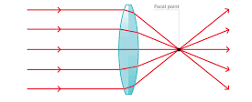

66-67. Label the nodes and the antinodes.
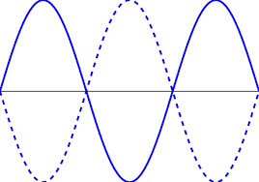

Timber Land

A real estate agent wished to divide the piece of land shown below into four equal portions with each portion having two trees on it. How would you recommend that he divide the land?

