Static Electricity Notes

I. Charge is a property of matter’s atomic structure. (tape demo)
A. Nucleus - contains neutrons that are neutral and protons that have a (positive) charge
B. Energy Levels - circling around the nucleus are electrons that have an opposite (or negative) charge
C. The charge of electrons and protons are equal but opposite to each other.
(electron + proton = neutron)
D. Electric charges exert a force much like gravity.
1)Force of gravity is stronger, the greater the mass of the 2 objects and is exponentially weaker the further the distance between them.
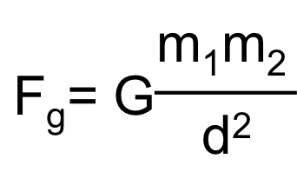
2)Force of electricity is stronger the greater the charge of the 2 objects and is exponentially weaker the further the distance between them.
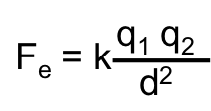
3) Gravity is a very weak force that is only felt when 1 or both objects are very massive. G=6.6 x 10⁻¹¹
4) Electricity is strong enough that very tiny objects such as electrons and protons are strongly attracted to or repelled by each other. K=9.0 x 10⁹
5) Opposite charges attract, like charges repel each other (similar to the poles of a magnet).
6) Electric charges are measured in coulombs (C).
Electrons and protons have a charge of less than a micro-coulomb (µC).
II. Net Charge - your body has 10²⁹ electrons and protons, but is electronically neutral or has a net charge of zero, because the charges cancel each other out.
III. Static electricity - is when electric charges build up but do not flow (electrostatics).
-Usually caused by the friction of moving objects (air masses/lightning, socks on the carpet, etc.)
-When electric charges flow continually it forms an electric current.
IV. Electrostatic induction - if a charged object (+) is brought near a neutral object, it will repel positive charges and attract negative charges in the neutral object causing it to become a dipole. (sticking a balloon to the wall)

