Simple Machine Notes
I. Types of Simple Machines
A. Levers – have a fulcrum, an effort arm, and a resistance arm.
1. Three types of levers are: FRE
a. 1st class –
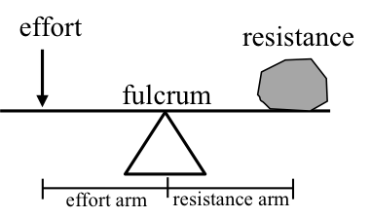
D_{R}
D_{E}
Ex. – hammer pulling nails, prying with a screwdriver, crowbar, seesaws
b. 2nd class –
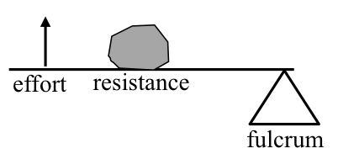
Ex. - doors, wheelbarrow
c. 3rd class –
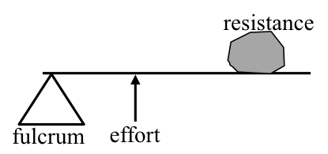
Ex. – brooms, hoe, baseball bat, fishing rod
2. Torque is force applied to the lever causing it to turn or rotate.
a. Effort torque = effort arm x effort force
b. Resistance torque = resistance arm x resistance force

B. Pulleys – Has a rope around a pulley(s) that is pulled to move an object.
Ex. - flag poles, cranes, window blinds
C. Wheel-and-axles - When one shaft is turned and it turns
another shaft/wheel/gear.
Ex. screwdriver, pencil sharpener, gears, winches
D. Inclined plane – Ramp that forms a right angle to the
ground
Ex. - wheelchair ramp, on-off ramps, overpasses
E. Screw - An inclined plane wrapped around a post.
Ex. - jar lids, wood screws, switchbacks
F. Wedges - A double inclined plane forming a point
Ex. – doorstop, any blade, scissors, etc.
II. All simple machines can be classified as either a lever or an inclined plane.
A. Pulleys and wheel-and-axles could be classified as circular levers with the axle being the fulcrum.
B. Screws and wedges are modified inclined planes.
III. Compound machines are machines that combine 2 or more simple machines.
Ex. – bicycle, scissors
IV. Mechanical Advantage - how many times a machine
multiplies the effort force.
A) Ideal mechanical advantages - the mechanical advantage of a machine if there were no friction or loss of energy.
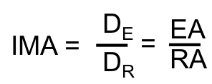
B) Actual mechanical advantage - the MA with friction
