Name ___________________________________ Date _____________________________ Period _______

Setting the Pace Quiz

Word Bank
ischemia capillaries tachycardia arteries diastole
bradycardia cardiac electrocardiography veins defibrillator
pulmonary electrocardiogram angina pectoris systole infarct
systemic fibrillation

1. If your heart beats too rapidly for its tissues to get enough oxygen, you would feel a crushing heart pain

known as ______________________________.

2. Having a heartbeat of more than one hundred beats per minutes is known as ________________________.

3. The technique that measures the electrical currents from the heart on the skin’s surface is called ______________________________________.
4. When heart cells begin to die because of a lack of O₂, a(n) __________________________ has occurred.
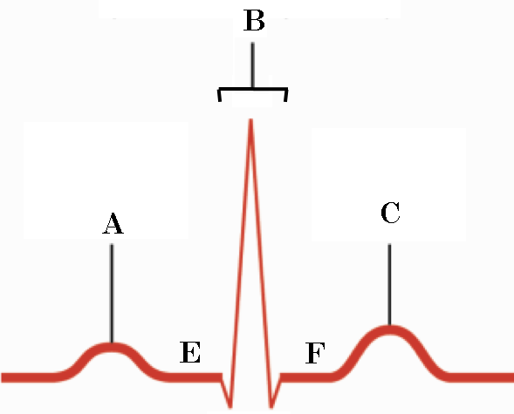
5. The picture at right is known as a(n) _____________________________.

6. Where on the drawing would the atria be contracting?

7. Where would the atrioventricular node be sending a signal?

8. Coronary veins are part of the _______________________ circulation.
9. During ___________________________, the ventricles would be relaxing.

10. An inadequate supply of blood to the heart tissue can lead to a condition known as __________________.

11-12. Describe how the electrical signals pass through the heart and cause it to beat.

Bonus:
Name the following condition:
1. 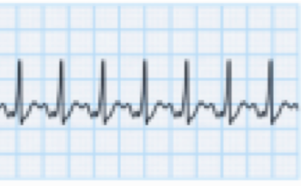

2. 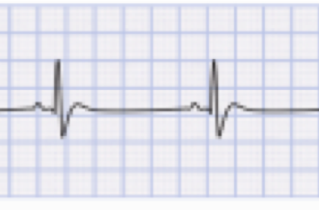

3. How many heartbeats are on number 2?

4. _______________________ are made out of nucleotides.

5. The process in which the cell uses messenger RNA to make a protein chain is known as

______________________________.

