Momentum

I. Momentum Is Inertia in Motion
A. Is conserved for all interactions where external forces don’t interfere.
B. formula is:
Momentum = mass x velocity
In equation form: $\vec{p}=m\vec{v}$
The letter p is used to represent momentum from Latin for impetus (push).
C. Momentum is a vector quantity
D. A moving object can have a large momentum if:
Its mass is large.
Its speed is large.
Or if both its mass and speed are large.

II. Impulse Changes Momentum
A. If momentum changes usually the velocity changes i.e. it accelerates which is caused by a force.
B. The greater the force, the greater the acceleration, the greater the change in velocity and the greater the change in momentum.
$a=\frac{F}{m}$ and $∆p=m∆v$
C. How long the force acts on the object is also important.
1) If you exert the same force over a longer period of time, a greater change in momentum results.
J = F_{net} • t
Impulse = force x time
measured in N•s or kg•m/s²
2) The impulse-momentum relationship.
F_{net} = m • a
F_{net} = m • Δ v
t
F_{net} • t = m • Δ v
Impulse = change in momentum
$$F∆t=∆mv$$

D. Interactions of Impulse and Momentum changes
1) Increasing Momentum by Increasing Force, Time, or Both
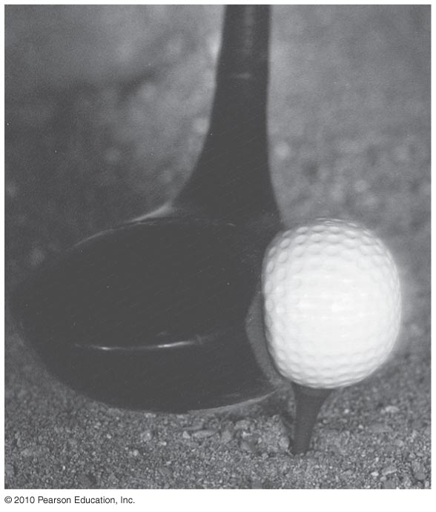
a) Long-range cannons, pistol vs. rifle have long barrels. The longer the barrel, the longer time the forces act on the bullet.
b) follow-through in baseball, golf, or tennis swing
c) lifting weights – more force more momentum change
2) Changing Momentum Over a Long Time Means Less Force
a) bungee jumping, hitting a haystack vs. wall, rolling with punch, catching a ball or an egg
*The same impulse doesn’t mean the same force or the same time; it means the same product of force and time.
3) Decreasing Momentum Over a Short Time Means More Force
Leaning into a punch, egg hitting a wall, kung fu
III. Momentum Change Is Greater When Bouncing Occurs
There is a greater impulse involved in objects that bounce. When an objects momentum changes to zero and then accelerates in opposite direction,
The shorter the time these changes in velocity occur the greater the force involved
-ball bouncing off a wall
IV. Momentum Is Conserved
In order to change momentum, you have to exert a net force for a period of time (net impulse)
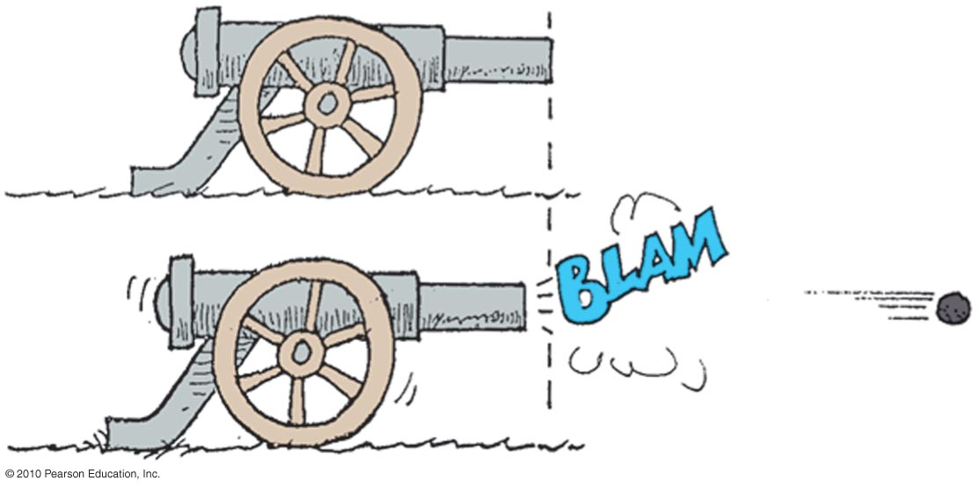
If there are no external forces acting on the objects, the total amount of momentum is conserved (doesn’t change), this is the law of conservation of momentum.

momentum =0
cannon’s momentum cannonball’s momentum
-Mv mV

Bug on the windshield – More force? Momentum?
What happens if you throw the bowling ball?
What if you fake throw the bowling ball?

VI. Momentum Is Conserved in Collisions
Momentum is conserved in collisions
net momentum_{before collision} = net momentum_{after collision}

Elastic collisions – when objects collide and are not permanently deformed and do not generate heat (bounce perfectly)

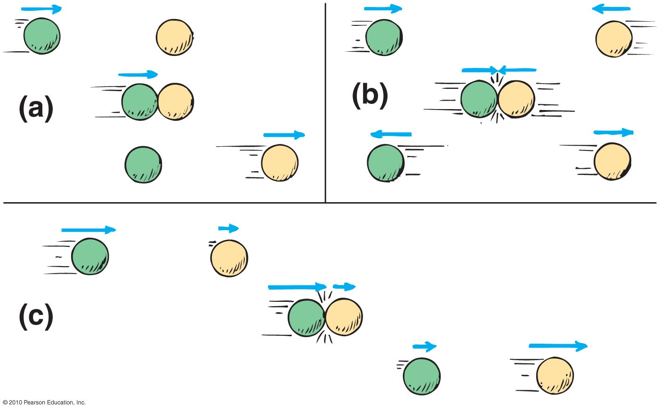
Inelastic collisions – both objects stick together or become entangled
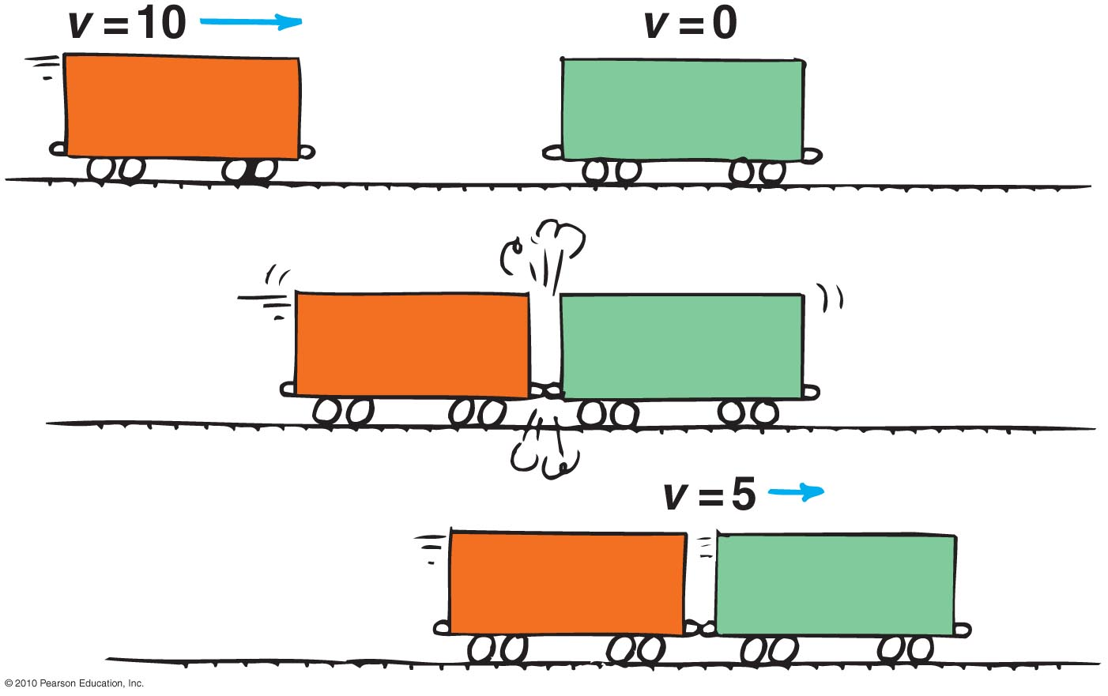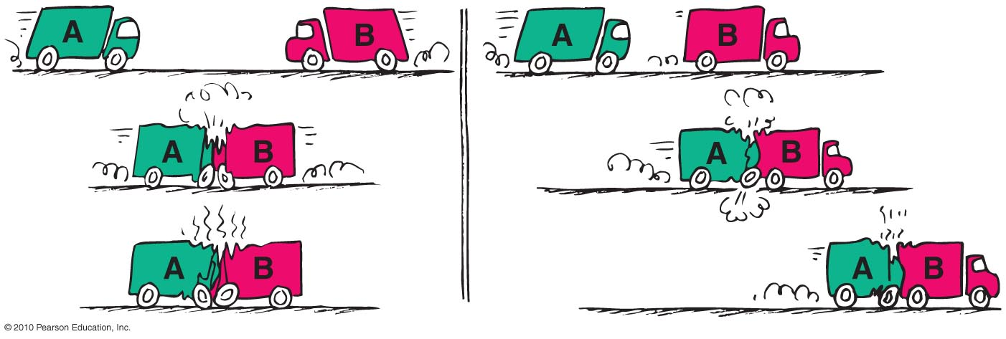

In the everyday world there are no perfectly elastic collisions and most collisions are either more or less elastic or inelastic.
At the atomic level, molecules always collide elasticly because their electrons repel each other and they never actually touch.

