Name _________________________________ Date _________________________________ Period ______
The Electrifying Review
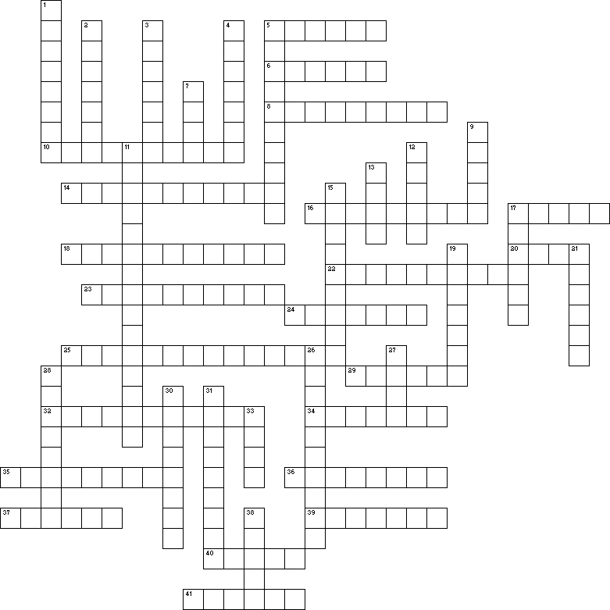

Across
5 Elements that loosely hold their valence electrons which means that they conduct electricity well.
6 The greater the _____ of a wire, the more resistance it has.
8 The resistance of a circuit is ___ proportional to the amount of current in a circuit.
10 How easy or hard it is for electricity to flow through a conductor.
14 Objects that resist the flow of electricity through a circuit.
16 An element that holds its valence electrons tightly which makes it a poor conductor.
17 These come in AA, AAA, C, and D and all have a voltage of 1.5 volts. They may be combined to make a battery.
18 The liquid that both of the chemicals in an alkaline battery are soaked in to create a chemical reaction.
20 The law that explains the relationship between current, resistance, and voltage.
22 Elements that have characteristics of conductors and insulators and are known as semiconductors.
23 What is measured when you use a multimeter to see if a circuit is closed or if it has a break in it.
24 The collection of cells that produce the electrical potential difference needed to make electrons flow through the circuit.
25 These are switched off by the magnetic field created by a current that is too much for a circuit to handle.
29 Hooking 2 batteries in parallel will _____ the current.
32 The type of current that comes from an electrical socket in your house.
34 The flow of electrons measured with an ammeter,
35 Voltage is the difference in electric ____ between 2 points.
36 The current of a circuit is ___ proportional to its voltage.
37 A circuit that has the same current throughout and splits the voltage between each resistor.
39 The type of instrument used to measure the amount of current running through a circuit.
40 Type of circuit that happens when a current finds an easier path that contains no resistors.
41 Type of current produced by a battery and can be positive or negative.

Down
1 An object that does not allow electricity to flow through it easily.
2 The units that are used to measure the number of electrons that are flowing through a circuit.
3 The path that electrons follow through conductors.
4 The end of the battery that loses electrons and gets a positive charge,
5 A device that can be used to measure continuity, voltage, resistance, or current.
7 A circuit that is not continuous.
9 Most alkaline cells have an electric potential of 1.5 ___.
11 Substances that have zero resistance at low (0-70 K) temperatures.
12 Units used to measure the frequency of an alternating current.
13 Units used to measure resistance.
15 Instrument used to measure the electric potential of a circuit.
17 A circuit that is continuous and allows electricity to flow through it.
19 The electrical "pressure" that causes electricity to flow through a circuit.
21 A device used to open and close circuits.
26 The type of energy that a battery produces.
27 Device used to shut down a circuit that is carrying too much current by melting a piece of metal, opening the circuit.
28 The bigger the ___ of a wire, the lower the resitance of the wire.
30 A circuit that uses more power because each branch has more current and voltage.
31 0.001 amperes
33 Outlet that monitors the amount of current leaving from and returning to the outlet and breaks the circuit if the amounts of current are not equal.
38 The end of the battery that the free electrons collect at.

