Name ___________________________________ Date ____________________________ Period _______
A Dilly of A Drawing
Turn your paper so it is wider than it is tall. From the top left hand corner of the paper, measure 8 cm and put a dot. Form this dot, measure down 38 mm and put a dot. From here you will be drawing lines.

1. Go 2 cm SW
2. Go 94 mm S
3. Go 19 mm SE
4. Go 1.4 cm W
5. Go 2.5 cm NW
6. Go 20 mm S
7. Go 1.3 cm SW
8. Go 1.2 cm W
9. Go 3 mm NE
10. Go 0.4 cm E
11. Go 0.8 cm NE
12. Go 2.7 cm N
13. Go 10 mm NW
14. Go 5.2 cm N
15. Go 5.0 cm NE
16. Go 3.3 cm E
17. Go 19 mm SW
18. Go 9.4 cm S
19. Go 1.9 cm SE
20. Go 19 mm E
21. Go 19 mm NW
22. Go 94 mm N
23. Go 1.9 cm NE
24. Go 4 mm E
25. Go 12.2 cm S
26. Go 4 mm E
27. Go 1.9 cm NE
28. Go 9.4 cm N
29. Go 19 mm NW
30. Go 19 mm E
31. Go 1.9 cm SE

32. Go 9.4 cm S
33. Go 1.9 SW
34. Go 19 mm E
35. Go 1.9 cm NE
36. Go 9.4 cm N
37. Go 19 mm NW
38. Go 6.6 cm W
39. Go 8.1 cm E
40. Go 50 mm SE
41. Go 10 mm S
42. Go 5 mm SE
43. Go 5 mm NE
44. Go 0.4 cm E
45. Go 3 mm NW
46. Go 1.1 cm N
47. Go 4 mm NE
48. Go 0.4 cm SE
49. Go 1.4 cm S
50. Go 3 mm E
(Continued on back)
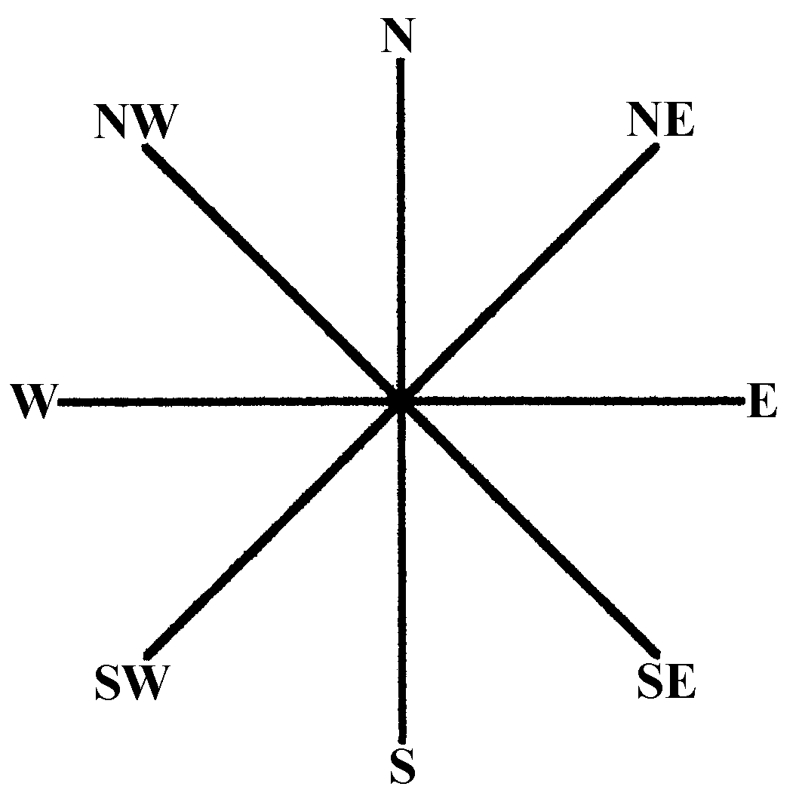
51. Go 9 mm SE
52. Go 0.9 cm S
53. Go 5 mm W
54. Go 4 mm NW
55. Go 0.4 cm SW
56. Go 0.4 cm SE
57. Go 4 mm NE
58. Go 5 mm E
59. Go 1.9 cm S
60. Go 1.3 cm SW
61. Go 0.3 cm W
62. Go 0.5 cm N
63. Go 5 mm S
64. Go 2 mm W
65. Go 7 mm NW
66. Go 1.2 cm N
67. Go 6 mm NW
68. Go 2.5 mm SW
69. Go 2.0 cm S
70. Go 4.9 cm SW
71. Go 1.5 cm W
72. Go 1.5 cm S
73. Go 5 mm E
74. Go 0.5 cm SE
75. Go 4 mm W
76. Go 3 mm NW
77. Go 3 mm SE
78. Go 0.4 cm W
79. Go 3 mm NW
80. Go 3 mm SE
81. Go 10 mm W
82. Go 5 mm NW
83. Go 1.5 cm N
84. Go 1.5 cm S
85. Go 0.5 cm SE
86. Go 0.4 cm W
87. Go 5 mm NW
88. Go 1.5 cm N
89. Go 5.4 cm W
90. Go 1.5 cm S
91. Go 5 mm E
92. Go 0.5 cm SE
93. Go 4 mm W
94. Go 0.3 cm NW
95. Go 3 mm SE
96. Go 4 mm W
97. Go 0.3 cm NW
98. Go 0.3 cm SE
99. Go 1.0 cm W
100. Go 0.5 cm NW
101. Go 1.5 cm N
102. Go 15 mm S
103. Go 5 mm SE
104. Go 0.4 cm W
105. Go 5 mm NW
106. Go 1.5 cm N
107. Go 17 mm E

