Name ______________________________________ Date _____________________________ Period ______

Current and Battery Quiz

T or F 1. Electricity can only flow through a circuit that is open.

2-3. What are two things that can be measured with a multimeter?

4-5. What units would they be measured in?

6. The electrical energy in a battery would be measured in what units?

7. Are metals better conductors or insulators?

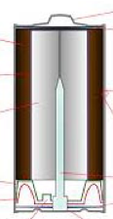
8. Why?

9. Is the picture at right a battery or a cell? Explain.

10. Label the positive and negative ends of the picture.

11. Which will last the longest, a D-cell or a 9-volt battery?

12. What type of energy conversion occurs in the battery of your cell phone when you are using it?

13. When the electric current takes a quicker path that avoids resistors or devices, this is called a

____________________________.

