Name ___________________________________ Date ______________________________ Period ______

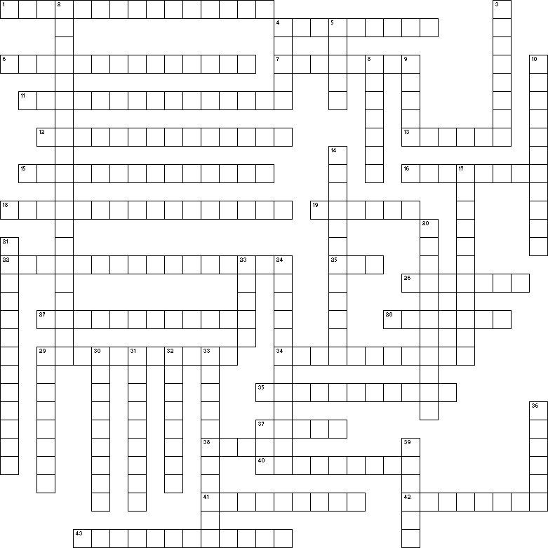
Circulation CW Review

Across
1 The rate at which the patient is breathing. One of the vital signs.
4 The veins with the lowest blood pressure in the body.
6 Devices that shock the heart in order to get it to reset itself to its normal heart rythym.
7 Colder temperatures would result in an ___ in your blood pressure.
11 When fatty plaque is deposited underneath the inner lining of an artery.
12 Places where pressure can be exerted on arteries to reduce the blood flow or places where the pulse can be taken.
13 This part of the nodal system sends the signals to the ventricle that cause them to contract.
15 Swelling caused by backed up blood flow when the left side of the heart fails.
16 When there is inadequate blood flow to the heart tissues.
18 Change in blood vessels caused by the fight or flight response.
19 This gender generally has a faster heart rate.
22 When the walls of the arteries become harder and inflexible.
25 Diagram or printout showing the electrical signals of the heart.
26 These organs have the biggest effect on your blood pressure by controlling the volume of fluid in the blood.
27 When the heart rate increases to the point that the heart simply flutters or shudders.
28 One of the ions that affect your heart rate.
29 When a catheter is used to inflate a balloon inside a blood vessel to open the lumen.
34 Hormone that increases the heart rate.
35 Another name for the heart's electrical conduction system.
37 The pressure exerted in the arteries when the ventricles contract.
38 When the heart is unable to pump enough blood to meet the body tissues need for O₂ and nutrients.
40 The number of times your heart beats per minute.
41 Medications that cause the kidney to form more urine and lower the blood pressure.
42 If the kidneys remove more water from the blood, it would cause the blood pressure to ___.
43 Change in a blood vessel by a factor, such as heat, that reduces your blood pressure.

Down
2 Type of swelling and pressure caused by failure of the right side of the heart.
3 This chemical causes vasoconstriction.
4 Blood vessels with valves that carry lower pressure blood in their larger lumens.
5 The artery with the highest blood pressure in the body.
8 This chemical causes vasodilation and lowers blood pressure when imbibed.
9 Swelling caused by increasing fluid levels.
10 When a person has less than sixty heartbeats per minute. It is usually not pathological.
14 The "silent killer" that causes your heart to work harder and wear out over time. BP is > 140/90.
17 When the systolic pressure is less than one hundred millimeters of mercury. Usually a sign of good physical condition or old age.
20 The only place in the circulatory system where substances can move in and out of the blood. Like a student on Saturday, they are found in beds.
21 The volume of blood pumped out of either side of the heart in one minute.
23 A wire mesh that is spread out and left in a blood vessel to keep its lumen open.
24 The amount of blood that is pumped out by one side of the heart each time the heart beats.
29 Blood vessels that have 3 layers, a smaller lumen, elastic walls, and a higher blood pressure.
30 Word used to describe the heart's self-contained electrical conduction system.
31 The sinoatrial node, which initiates the heartbeat.
32 Blood pressure is also referred to as ______ pressure.
33 An extremely fast heart rate that can lead to fibrillation.
36 The "pacemaker" of the heart.
39 One of the factors that affects heart rate.

