Name ________________________________________ Date __________________________ Period _____

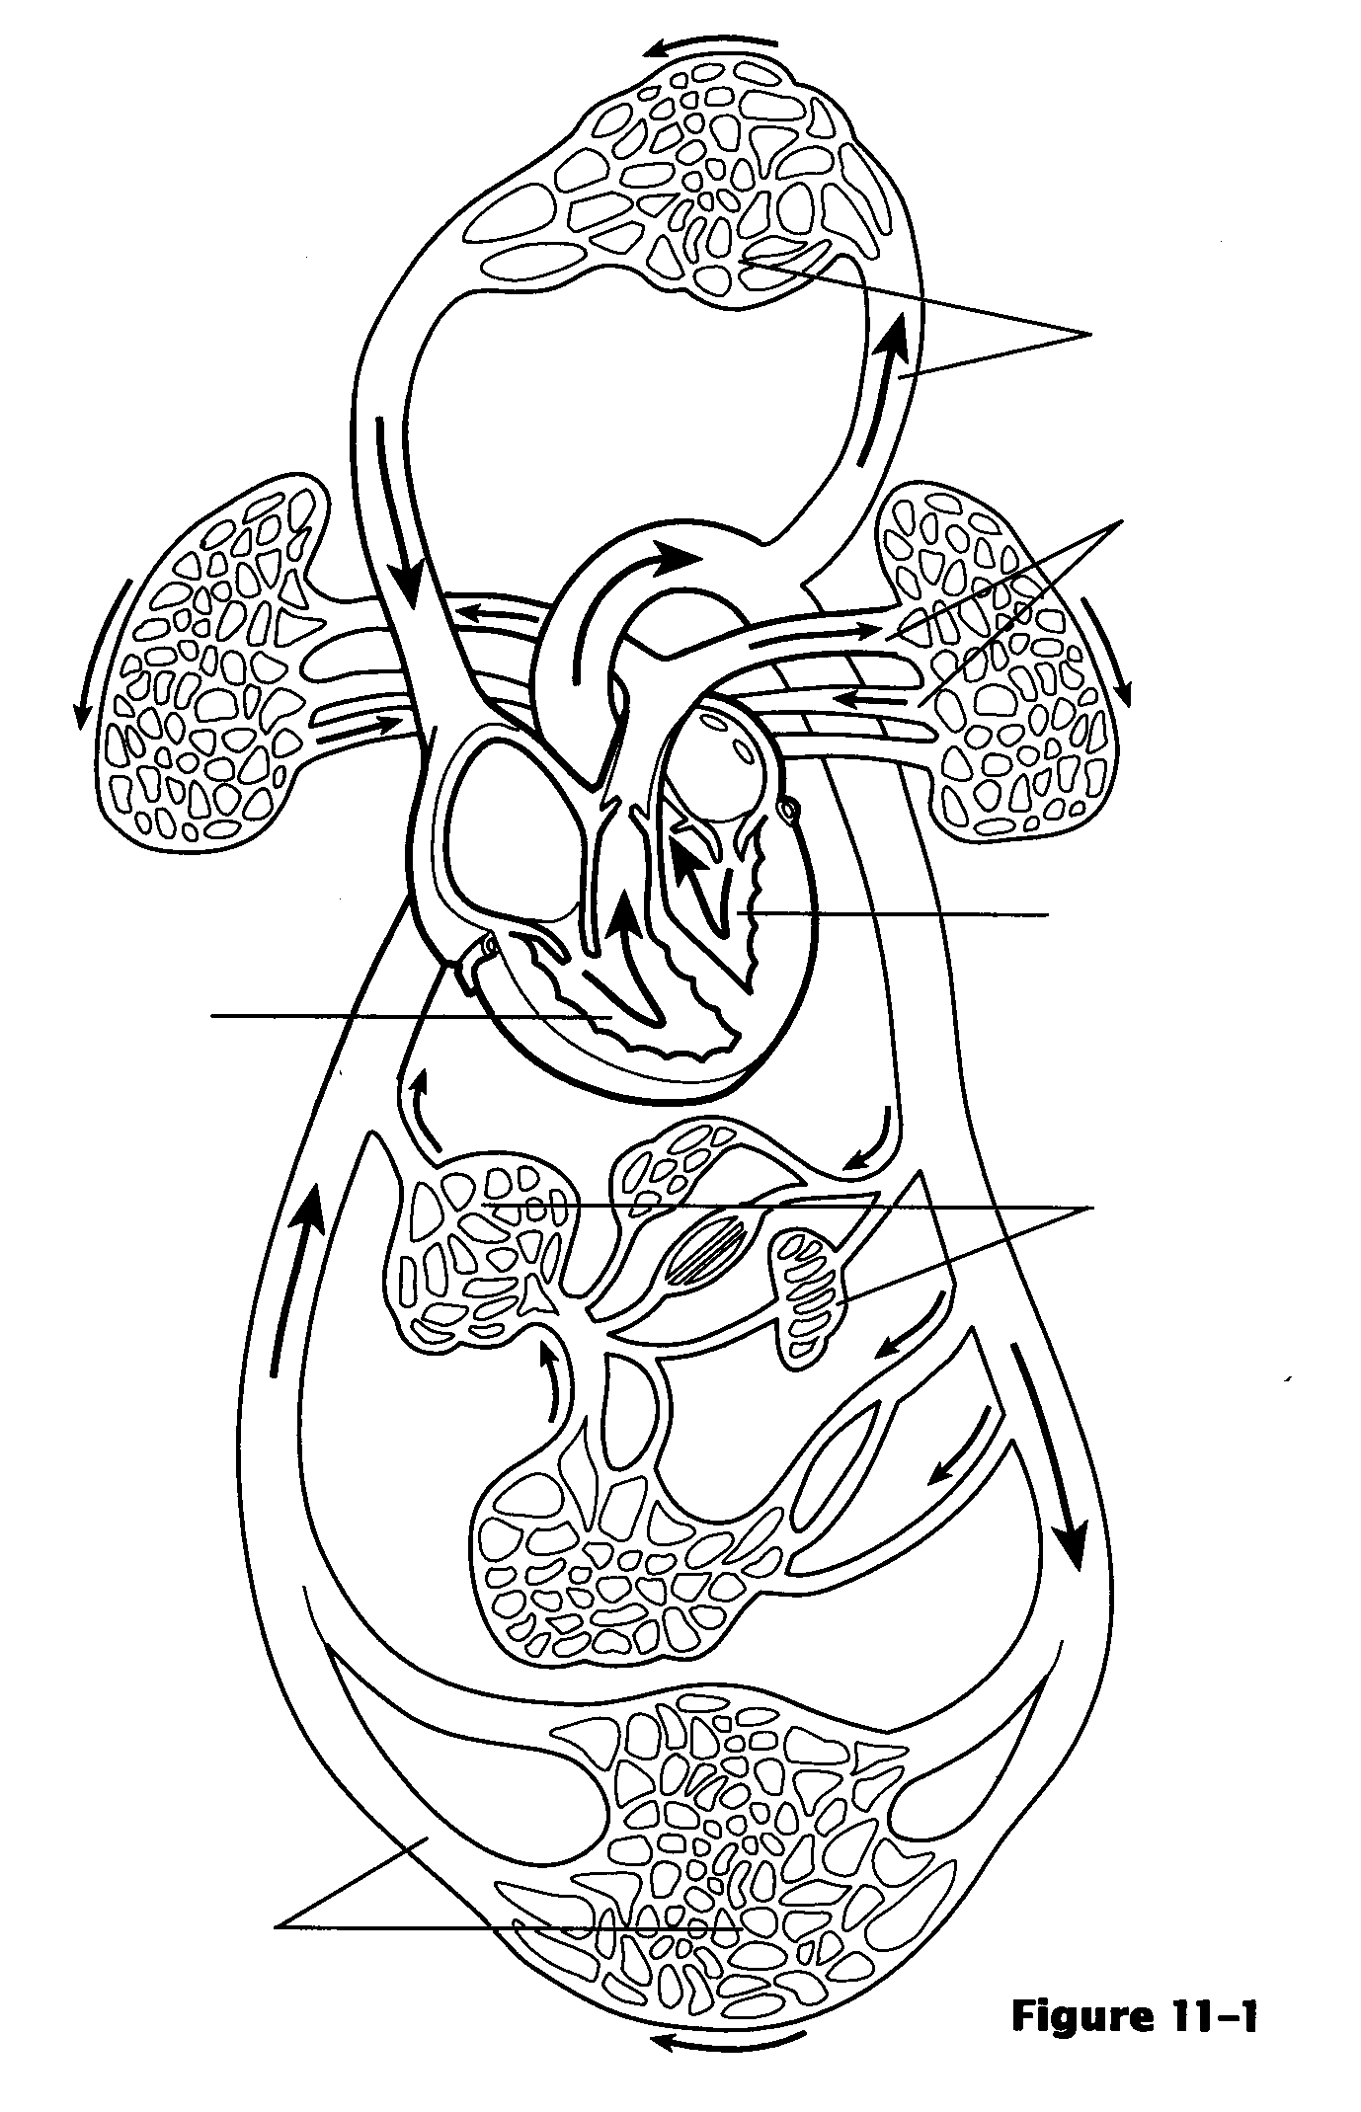
Cardiovascular System WS

1. Place the following letters by the appropriate line on the drawings.
A. Vessels serving head and upper arms.
B. Vessels serving the trunk of the body and the legs.
C. Vessels serving the viscera (“guts”)
D. Pulmonary circulation
E. Pulmonary “pump”
F. Systemic pump

2. Color regions containing O₂–rich blood
red and the areas that contain O₂–poor
blood blue.

3. Fill in the blanks below with the word
that belong in the following paragraph
that describes the flow of blood through
the cardiovascular system.

________________________________ 1.
________________________________ 2.
________________________________ 3.
________________________________ 4.
________________________________ 5.
________________________________ 6.
________________________________ 7. ________________________________ 11.
________________________________ 8. ________________________________ 12.
________________________________ 9. ________________________________ 13.
________________________________ 10. ________________________________ 14.
Blood returning from the upper body empties into the __1_. Returning blood from the lower body empties into the __2__. Both of these large veins empty into the __3__. The blood then passes through the __4__ valve into the __5__. When the blood is pumped out of this chamber it passes through the __6__ valve, into the __7__ which carries blood to the __8__ where they pick up O₂. The blood returns to the heart through the __9__ which bring the blood to the __10__. It passes through the __11__ valve into the __12__. When it is pumped out of this chamber, it passes through the __13__ valve into the __14__, which is the largest artery in the body. Various arteries branch off to carry the blood throughout the body.
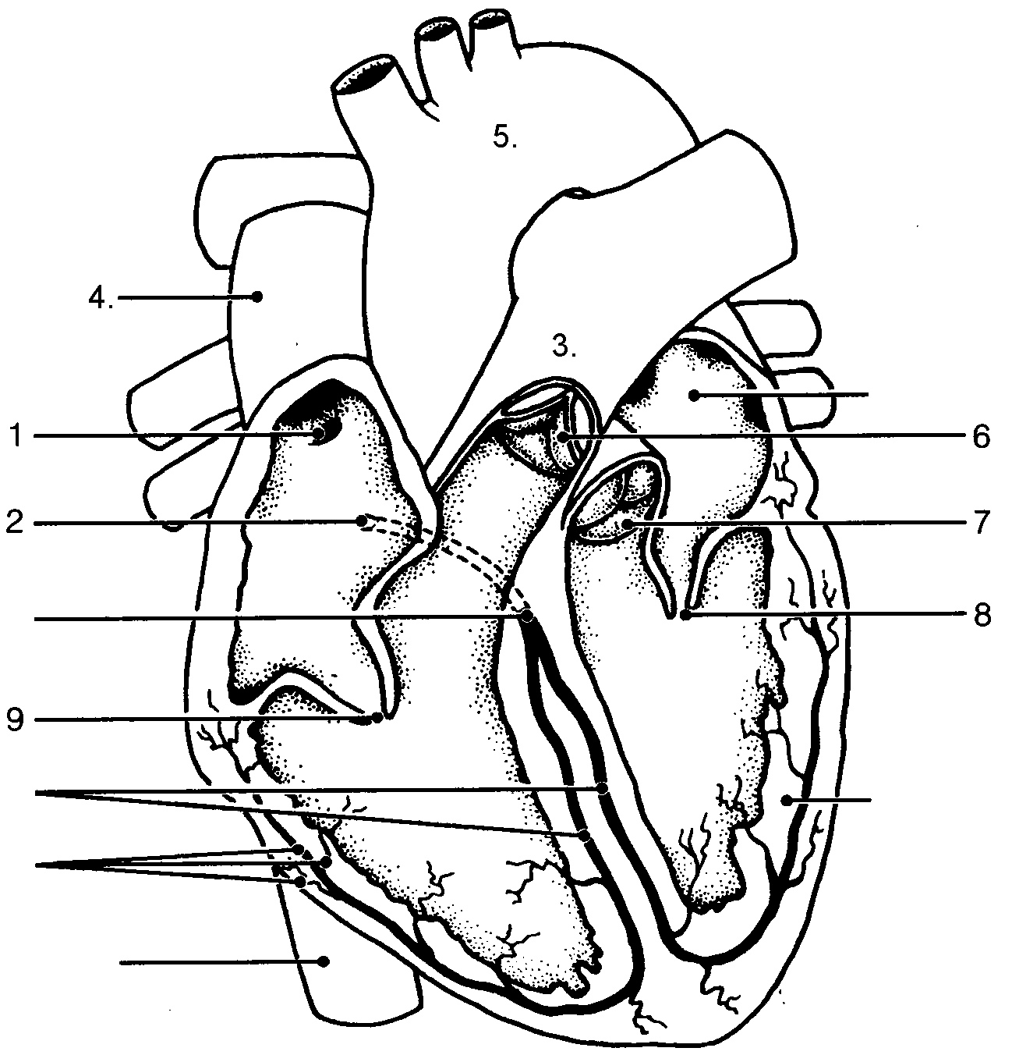
4. Fill in the blanks below with the name of the correct valve, node, or blood vessel.

________________________________*1.
________________________________*2.
________________________________ 3.
________________________________ 4.
________________________________ 5.
________________________________ 6.
________________________________ 7.
11
________________________________ 8.
________________________________ 9.
10
________________________________ 10.
________________________________ 11.

5. Put the number of the correct heart part in the blank for each description.

_____ A. AV valve with 3 flaps
_____ B. _____ C. Semilunar valve with 3 flaps.
_____*D. The pacemaker of the intrinsic conduction system.
_____ E. _____ F. These prevent backflow into atria when the ventricles are contracting.
_____ G. _____ H. These make the “dub” or second heart sound when they close.
_____*I. The node in the conduction system where the signal is temporarily delayed.
_____ J. _____ K. These make the “lub” or first heart sound when they close.
_____ L. AV flap with 2 flaps.

*6. On the EKG (electrocardiogram), label the T wave, the P wave, and the QRS complex. Then using a colored pencil, bracket the portion of the EKG that shows one cardiac cycle. Then label the spots on the EKG where the ventricles would be contracting, the atria would be contracting, the AV node is firing, and the SA node is firing.

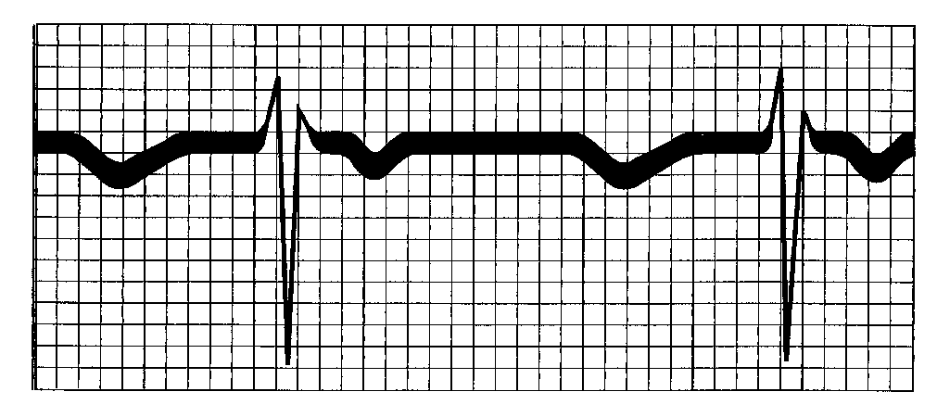

*7. Put the correct word in the blank that matches the definition or description.

_______________________ A. Higher arterial pressure reading caused by the contraction of the ventricles.
_______________________ B. Chest pain resulting from ischemia of the myocardium.

_______________________ ˚C. Chamber of the heart that has just emptied when you hear the first heart sound.
_______________________ ˚D. After the second heart sound, this chamber begins to fill with blood.
_______________________ E. Lower arterial pressure during the relaxation of the ventricles.
_______________________ F. Abnormal heart sounds that indicate valve problems.
_______________________ G. A recording of the electrical activity of the heart
_______________________ H. A heartbeat of less than 60 heartbeats per minute.
_______________________ ˚I. Chamber of the heart that has just filled when you hear the first heart sound.
_______________________ ˚J. Chamber of the heart that has just emptied when you hear the second heart sound.
_______________________ K. When there is an inadequate blood supply to the heart.
_______________________ L. An abnormally high heartbeat of greater than 100 beats/minute.

8. Circle the term that does not belong with the other terms.
*A. QRS complex T wave P wave Electrical activity of the ventricles
B. Tricuspid valve Mitral valve Bicuspid valve Left AV valve
*C. Ishemia Heart block Infarct Heart attack
D. Left side of the heart Pulmonary trunk Inferior vena cava Right side of the heart
E. “Lub” sound Aortic semilunar valve Tricuspid valve Chordae tendinae
F. AV valves opened Semilunar valves opened Ventricular contraction AV valves closed

9. Label the picture of the heart’s exterior surface.

_____________________________ 1.
_____________________________ 2.
_____________________________ 3.
_____________________________ 4.
_____________________________ 5.
_____________________________ 6.
_____________________________ 7.
_____________________________ 8.
_____________________________ 9.
_____________________________ 10.
_____________________________ 11.
_____________________________ 12.
_____________________________ 13.
_____________________________ 14. _____________________________ 15.

*10. Check all factors that would result in an increase of cardiac output by increasing either the heart rate or
stroke volume.

_____ A. hemorrhage _____ B. high blood pressure
_____ C. fear _____ D. activation of sympathetic nervous system
_____ E. exercise _____ F. exercise
_____ G. thyroxine _____ H. fever
_____ I. epinephrine _____ J. activation of the vagus nerves

*11. What is meant by peripheral congestion and pulmonary congestion, what are the symptoms of each, and
what causes each?

*12. What do the symbols in this equation stand for?
CO = HR x SV

*13. If I have a heart rate of 83 bpm and a stroke volume of 60 ml per beat, what would my cardiac output be?

*14. Identify the following types of blood vessels and give as many reasons as possible for why you labeled
each one as you did.

*15. Color code the circles and the structures on the drawing. Then label each of the lines on the drawing. Some answers will be colored and labeled.

16. Use your book to label the major arteries of the body on the drawing below.

17. Use your book to label the major veins of the body on the drawing below.

