Name ____________________________________ Date ______________________________ Period _____

Cardiovascular Test

Matching –Answers may be used as often as needed. If there’s more than one correct answer, put all of them.
_____ 1. The fibrous, protective sac that surrounds the heart. A) pulmonary
_____ 2. Infection of the smooth inner layer that lines the chambers of the heart. B) tricuspid valve
_____ 3. The left side of the heart pumps blood into the ____ circulation. C) pulse
_____ 4. These valves would be open when the atria are contracting. (2) D) ventricles
_____ 5. The serous fluid lubricates these two layers to reduce friction. (2) E) systemic
_____ 6. When the pericardium and the epicardium adhere to each other. F) aortic semilunar
_____ 7. The pressure wave caused by the contraction of the ventricles. G) pericarditis
_____ 8. Valves that do not fit together properly. H) myocardium
_____ 9. Blood going to the lungs leaves the heart through the ____ valve. I) endocardium
_____ 10. Layer of the heart that is made of cardiac muscles. J) bicuspid valve
_____ 11. The “dup” heart sound is caused by the closing of these valves. (2) K) atria
_____ 12. The lining that when infected can cause valves to become stiff. L) epicardium
_____ 13. The right AV valve. M) incompetent
_____ 14. These chambers of the heart are known as pumping chambers. N) pulmonary semilunar
_____ 15. The right side of the heart pumps blood into the ____ circulation. O) endocaritis
_____ 16. This has connective tissue that anchors the heart to the diaphragm P) mitral valve
and sternum.
_____ 17. Condition caused by a lack of serous fluid. Q) parietal pericardium

True or False
_____ 17. The chordinae tendinae contract and pull the AV valves to close them.
_____ 18. The tricuspid valve would be open except when the atria are contracting.
_____ 19. Pulse sites can be used as pressure points to slow down blood flow from a major injury.
_____ 20. The left AV valve can also be called the mitral valve.
_____ 21. The aortic semilunar valve is open except when the ventricles are contracting.
_____ 22. Pig heart valves may be used to replace human heart valves.
_____ 23. The closing of the semilunar valves cause the second heart sound.
_____ 24. The fossa ovalis is the scar tissue from a hole that connected the atria in a fetal heart.
_____ 25. Valvular stenosis is caused by calcium deposits in the valves.
_____ 26. The ventricles are the chambers of the heart that receive blood from the body.
Short Answer
27. What condition is caused by endocarditis?

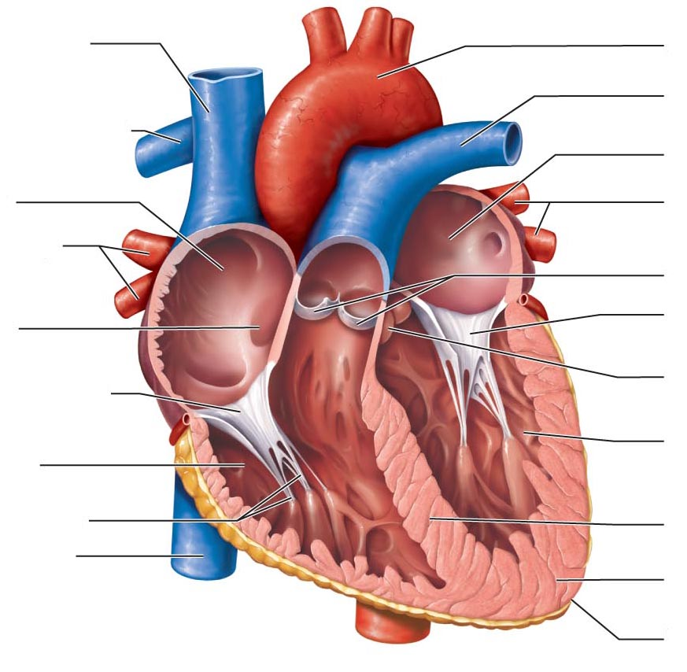
Label the drawing below from your word bank.
35
29
28
33
30
32
34
31

____________________________ 28.
____________________________ 29.
____________________________ 30.
____________________________ 31.
____________________________ 32.
____________________________ 33.
____________________________ 34.
____________________________ 35.

When the blood is pumped out of this chamber it passes through the _36_ valve, into the _37_, which carry to blood to the lungs. The blood returns from the lungs to the heart through the _38_ which bring the blood to the _39_. It passes through the _40_ valve into the _41_. When it is pumped out of this chamber, it passes through the __42__ valve into the _43_. Various arteries branch off to carry the blood throughout the body eventually passing through capillary beds, before entering veins to return to the heart. Blood returning from the upper body empties into the _44_. Returning blood from the lower body empties into the _45_. Both of these large veins empty into the _46_. The blood then passes through the _47_ valve into the _48_.

___________________________________ 36. ___________________________________ 43.
___________________________________ 37. ___________________________________ 44.
___________________________________ 38. ___________________________________ 45.
___________________________________ 39. ___________________________________ 46.
___________________________________ 40. ___________________________________ 47.
___________________________________ 41. ___________________________________ 48.
___________________________________ 42.

50.
55.
54.
49.
53.
52.
51.

___________________________________ 49. ___________________________________ 53.
___________________________________ 50. ___________________________________ 54.
___________________________________ 51. ___________________________________ 55.
___________________________________ 52.

56. __________________________________

57. __________________________________

58. __________________________________

59. __________________________________

Tell if blood at the following points would O₂-rich or
O₂-poor.
60. F
61. B
62. G
Tell if blood at these points would be in the systemic or pulmonary circulation.

63. E

64. H

