Name ______________________________________ Date ___________________________ Period_______

Cardiovascular Review
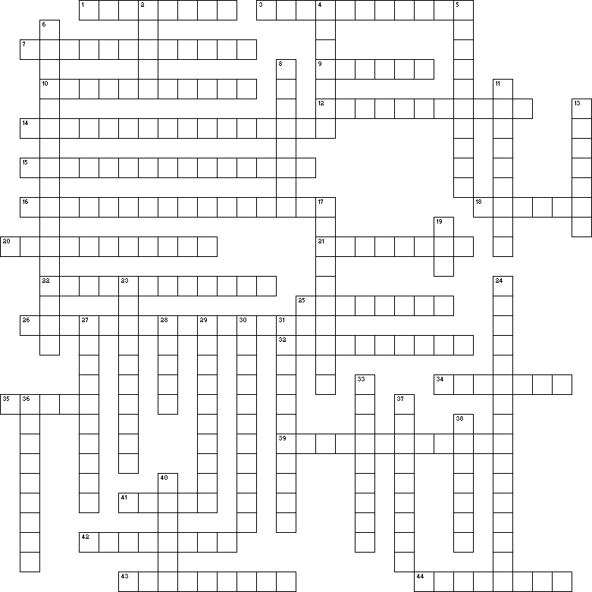

Across
1 The valves that close when the ventricles are full of blood and stay closed while the ventricles contract.
3 The fibrous, protective sac that covers the heart and anchors it to the sternum and diaphragm.
7 An infection of the smooth inner layer of the heart that can cause valve trouble.
9 Semilunar valve that blood leaving the left ventricle passes through.
10 The smooth inner layer of the heart that helps the blood flow smoothly through the heart.
12 Tiny blood vessels that form "beds" that connect arteries and veins.
14 A solution for incompetent valves to avoid congestive heart failure down the road.
15 Branch off the aorta that carries blood to the head and arms of the body.
16 Incompetent heart valves that have stiffened due to repeated attacks of endocarditis.
18 Crushing heart pain caused by a lack of oxygen in the heart tissue.
20 The groove on the interatrial septum that marks where the hole connecting the atria in the fetal heart used
to be.
21 The valve between the left atrium and left ventricle, also known as the mitral valve.
22 An infection of the tough, fibrous sac that protects the heart.
25 When blood leaks through valves and flows the wrong direction.
26 Blood vessels that have the highest level of oxygen in the body.
32 The smooth outer layer of the heart that is next to the parietal pericardium.
34 Vein that takes blood from the liver to the inferior vena cava.
35 The receiving chambers of the heart.
39 The hole in the fetal heart that allows blood to pass from the right atrium to the left atrium, bypassing the
non-functioning fetal lungs
41 Blood vessels that carry the blood back to the heart.
42 The vena cava that the brachiocephalic vein empties into.
43 The right ventricle pumps blood into this circulation.
44 The circulation that the left ventricle pumps into.

Down
2 Main artery carrying oxygenated blood away from the heart.
4 When heart cells begin to die from a lack of oxygen.
5 A "coronary" caused by a prolonged lack of oxygen in heart tissue is known as a ____ infarction.
6 The wall separating the atria of the heart.
8 Blood vessels that carry blood away from the heart, usually with highly oxygenated blood.
11 Valves that close to cause the "dub," or second heart sound,
13 The major vein carrying blood from the head region back toward the heart.
17 The artery that passes under the clavicle on the way to the arm.
19 Heart valves from this animal can be chemically treated and used in humans.
23 Describes a condition that a person is born with as opposed to one that develops later in life.
24 The "heartstrings" that keep the AV valves from opening too far and leaking blood into the atria.
27 The thick middle layer of heart tissue.
28 Veins and arteries that carry blood to and from the kidneys.
29 The chambers of the heart that emptied just before you hear the second heart sound.
30 A general word that describes valves that do not work properly
31 Pericarditis causes a lack of _____ which results in painful friction between the pericardium and the
epicardium.
33 The only arteries in the body that have low oxygen levels.
36 The valve that separates an atrium and a ventricle and is made of three flaps.
37 Describes valves that are man-made.
38 The main artery that carries blood to the head region.
40 The left AV valve is also known as the ____ valve.

