Name ____________________________________ Date ________________________ Class _________

Blood Study Guide

1. Blood is considered both a ________________ tissue and ___________________________ tissue. The living blood cells, or _______________________ __________________, are suspended in the fluid part of the blood known as _______________________. The formed elements of the blood include the ________ _______________ _____________, or RBCs, which make up _______% of the blood, and the thin ___________ _______________, which is composed of __________ _________ ___________ and _______________ and is _____% of the blood. The remaining ______% of the blood is made of plasma.
The percentage of the blood made up of RBCs is known as the _________________________.
The pH of human blood is usually between ________ and _______, which means it is slightly _______________. Its temperature is usually about ______________, which is _____________ than normal body temperature. In an adult male, the blood usually has a volume of about _______ liters.

2. Name three plasma proteins and tell what they are used for.

3. Which organs make adjustments if the blood’s pH is too high or too low?

Protein levels?

4. How do RBCs differ from most other body cells?

5. How do the following characteristics make RBCs efficient oxygen transporters:
few mitochondria

anaerobic metabolism

shape

6. T or F. The number of RBCs determine the oxygen levels in the blood. Explain.

7. What is anemia? What 2 things cause it?

8. Name six circumstances that can result in different types of anemia.

9. What happens to the red blood cells of people with sickle-cell anemia (SCA)?

10. What is meant if someone has sickle-cell trait (SCT)? How is this an advantage?

11. What is polycythemia, what can cause it, and is it beneficial or harmful?

12. How are WBCs different than RBCs?

13. Define diapedesis -

positive chemotaxis -

ameboid motion –

14. What are leukocytosis and leukopenia and what are they caused by?

15. In leukemia, cancerous bone marrow produces many white blood cells in a short time. Why is this a
problem?

16. Identify the cell type(s) or blood elements that fit the following descriptions. Insert the correct term or
letter response in the spaces provided.
A. Red blood cell D. Basophil G. Lymphocyte
B. Megakaryocyte E. Monocyte H. Formed elements
C. Eosinophil F. Neutrophil I. Plasma
____ 1. Most numerous leukocyte
____ 2. ____ 3. ____ 4. Granular leukocytes
____ 5. Also called an erythrocyte; anucleate
____ 6. ____ 7. Actively phagocytic leukocytes
____ 8. ____ 9. Agranular leukocytes
____ 10. Fragments to form platelets
_ ___ 11. (A) through (G) are examples of these
____ 12. Increases during allergy attacks
____ 13. Releases histamine during inflammatory reactions
____ 14. After originating in bone marrow, may be formed in lymphoid tissue
____ 15. Contains hemoglobin
____ 16. Primarily water, noncellular; the fluid matrix of blood
____ 17. Increases in number during prolonged infections
____ 18. Least numerous leukocyte
____ 19. ____ 20. Also called white blood cells (#19-23) ,
____ 21. ____ 22. ____ 23.

17. Platelets are not cells. Explain this statement.

18. What is hematopoiesis and where does it occur in adults?

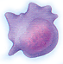
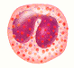
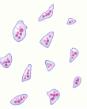
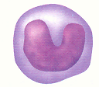
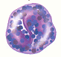
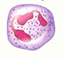
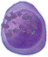
A
B
C
D
E
F
G
H
I
J
19. Label the stem cells and blood cells in the
blanks below .
A. ________________________________
B. ________________________________
C. ________________________________
D. ________________________________
E. ________________________________
F. ________________________________
G. ________________________________
H. ________________________________
I. ________________________________
J. ________________________________

20. How long do RBCs live? What happens to them when they “die”? How long does it take for a new
RBC to form?

21. Cancer patients being treated with chemotherapy drugs designed to destroy rapidly dividing cells are
monitored closely for changes in their RBC and WBC counts. Why?

22. Figure 10-1 depicts in incomplete form the erythropoietin mechanism for regulating the rate of
erythropoiesis. Complete the statements that have answer blanks, and then choose colors (other than
yellow) for the color-coding circles and corresponding structures on the diagram. Color all arrows on
the diagram yellow. Finally, indicate the normal life span of erythrocytes.

0 Kidney 0 Red bone marrow 0 RBCs
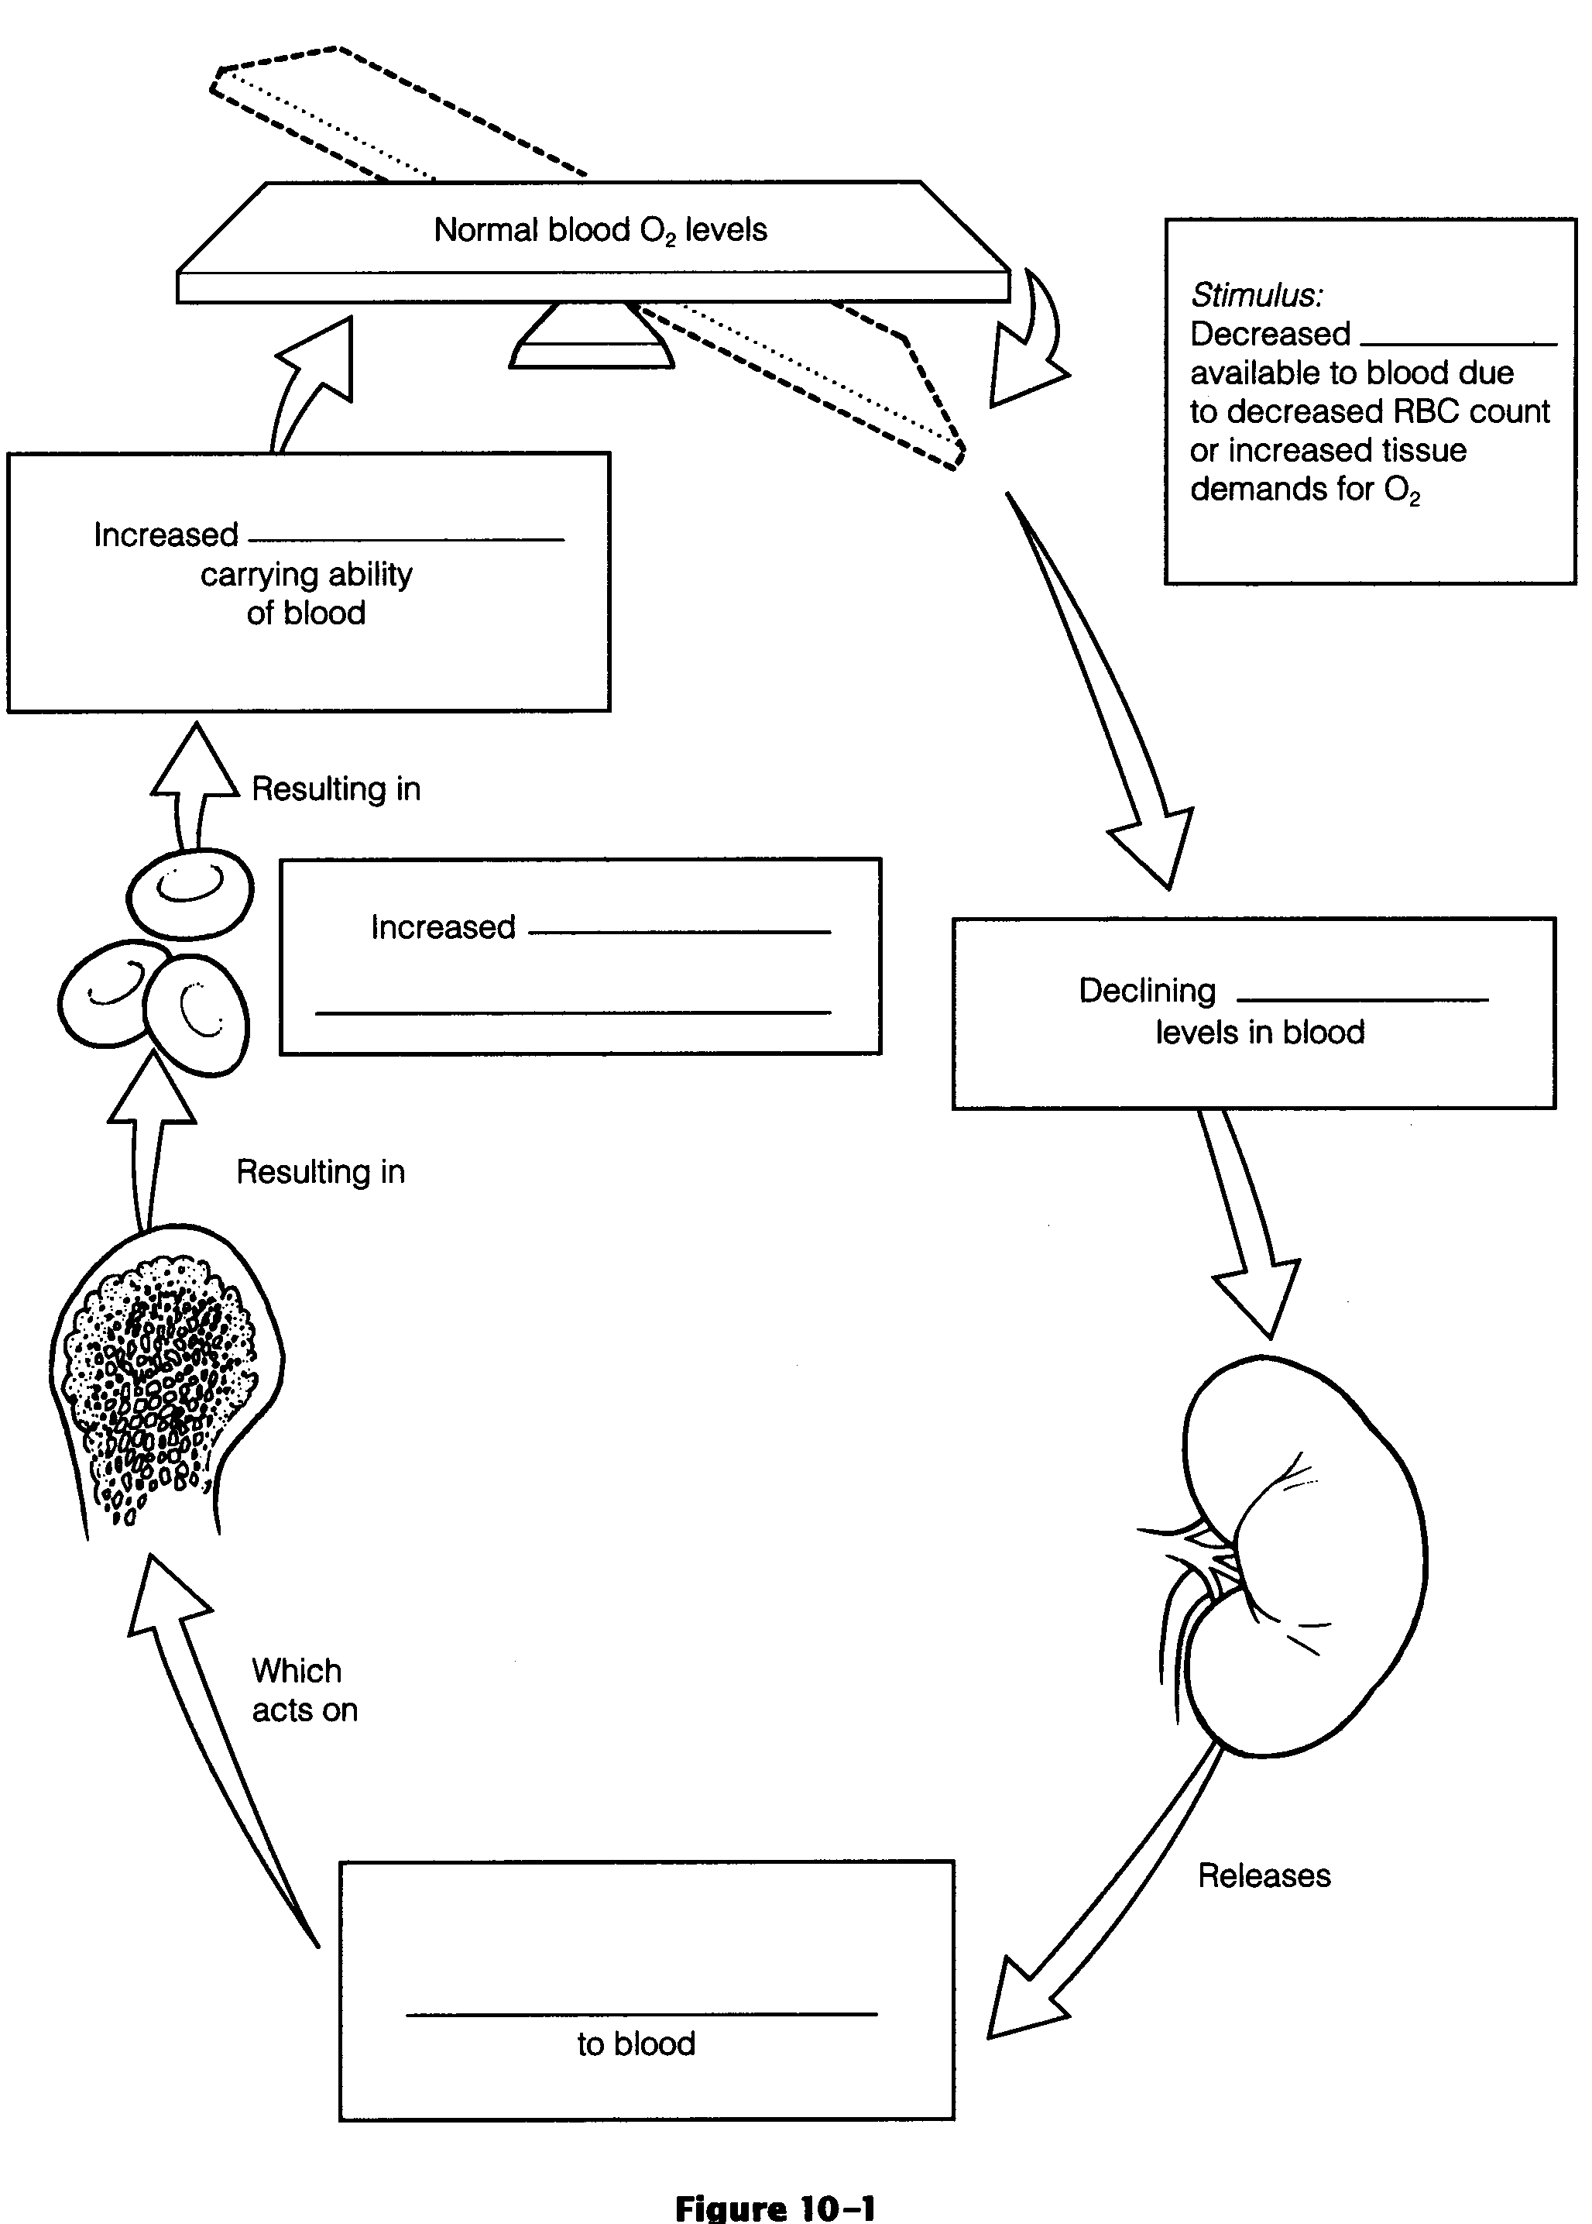
23. Check all the factors that would serve as stimuli for erythropoiesis.
_____ 1. Hemorrhage _____ 3. Living at a high altitude
_____ 2. Aerobic exercise _____ 4. Breathing pure oxygen

24. What hormones control WBC formation? What causes the release of these hormones?

25. What is done to test for leukemia?

26. What is hemostasis? Name the three phases of hemostasis and summarize what occurs in each phase.

27. Define thrombus –

coronary thrombosis –

embolus –

cerebral embolus -

28. What are some factors that can cause undesirable clotting? How can it be prevented?

29. For the following diseases, explain the causes, symptoms and treatment.
Thrombocytopenia -

Hemophilia –

Correctly respond to five questions (#32-36) referring to the following situation. Mrs. Carlyle is pregnant for the first time. Her blood type is Rh negative, her husband is Rh positive, and their first child has been determined to be Rh positive. Ordinarily, the first such pregnancy causes no major problems, but
baby Carlyle is born blue and cyanotic.
32. What is this condition, a result of Rh incompatibility, called?

33. Why is the baby cyanotic?

34. Because this is Mrs. Carlyle's first pregnancy, how can you account for the baby's problem?

35. Assume that baby Carlyle was born pink and healthy. What measures should be taken to prevent
the previously described situation from happening in a second pregnancy with an Rh-positive baby?

36. Mrs. Carlyle's sister has had two miscarriages before seeking medical help with her third
pregnancy. Blood typing shows that she, like her sister, is Rh negative; her husband is Rh
positive. What course of treatment will be followed?

37. What blood type is the universal donor? the universal recipient?

38. When a person is given a transfusion of mismatched blood, a transfusion reaction occurs. Describe the
sequence of events that occur during a transfusion reaction.

39. Ms. Pratt is claiming that Mr. X is the father of her child. Ms. Pratt's blood type is 0 negative. Her
baby boy has type A positive blood. Mr. X's blood is typed and found to be B positive. Could he be
the father of her child?

If not, what blood type would the father be expected to have?
DEVELOPMENTAL ASPECTS OF BLOOD
40. Complete the following statements by inserting your responses in the answer blanks.
A fetus has a special type of hemoglobin, hemoglobin _____________________ that has a particularly high affinity for oxygen. After birth, the infant's fetal RBCs are rapidly destroyed and replaced by hemoglobin A-containing RBCs. When the immature infant liver cannot keep pace with the demands to rid the body of hemoglobin breakdown products, the infant's tissues become yellowed, or ___________________.
Genetic factors lead to several congenital diseases concerning the blood. An anemia in which RBCs become sharp and "log- jam" in the blood vessels under conditions of low-oxygen tension in the blood is _____________________ anemia. Bleeder's disease, or _____________________, is a result of a deficiency of certain clotting factors. Diet is important to normal blood formation. Women are particularly prone to _____________________ deficiency anemia because of their monthly menses. A decreased efficiency of the gastric mucosa makes elderly individuals particularly susceptible to ________________ anemia as a result of a lack of intrinsic factor, which is necessary for vitamin _____________ absorption. An important problem in aged individuals is their tendency to form undesirable clots, or _____________. Both the young and the elderly are at risk for cancer of the blood, or _____________________.

41. A red marrow biopsy is ordered for two patients-one a young child and the other an adult. The
specimen is taken from the tibia of the child but from the iliac crest of the adult. Explain why
different sites are used to obtain marrow samples in adults and children. (You might want to check
Chapter 5 for this one.)

