Name _______________________________________ Date ____________________________ Period ____

Blood Crossword Review

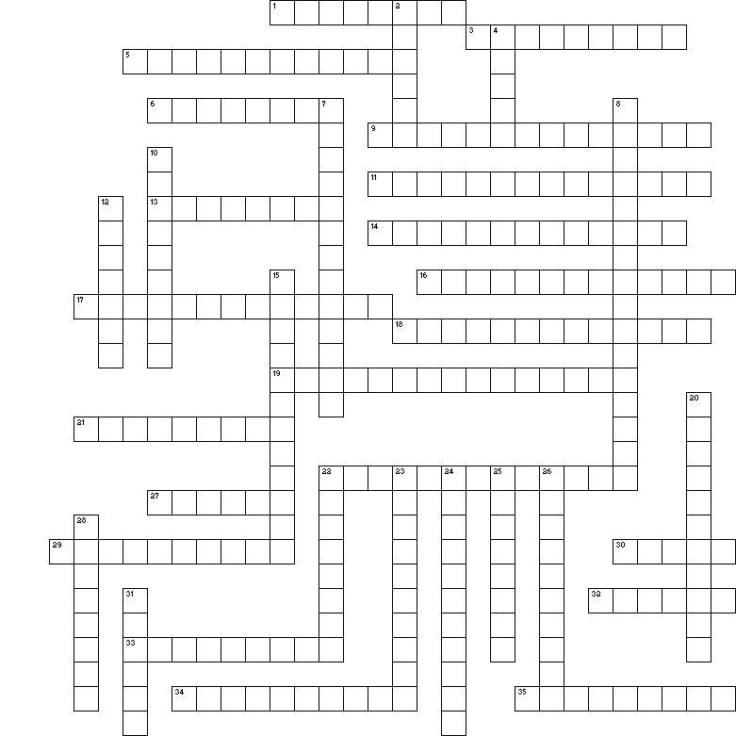

Across
1 Leukocytes that release histamines during inflammation reactions.
3 A lack of these is known as thrombocytopenia.
5 In a cut, it is formed when platelets stick to damaged tissue.
6 If a person is deficient in this vitamin, thrombocytopenia may result.
9 Hormone released by the kidney when the oxygen levels in the blood is low.
11 A person with blood type O (esp. O⁻) is known as a ___ ___.
13 The pH of the blood is usually about 7.4 which means that it is _______.
14 Large cells that explode forming fragments that become platelets.
16 The process by which new blood cells are produced by the red bone marrow.
17 White blood cells are able to move through body tissues by pulling themselves on "arms" of cytoplasm. This is known as ______.
18 The shape of a red blood cell that allows maximum surface area.
19 When a floating embolus blocks a blood vessel in the brain causing a stroke.
21 The layer of a centrifuged blood sample that contains the leukocytes and the platelets.
22 Red bone marrow is also known as ____.
27 A shot that is given to a mom that is Rh⁻ to keep her from producing antibodies that attack Rh+ antigens.
29 Disease caused by a lack of clotting factors that should be present in the blood.
30 Hemoglobin that has a very high affinity for oxygen. It is rapidly destroyed after the baby is born.
32 When there is a decrease in the oxygen-carrying capacity of the blood.
33 Erythrocytes are____, which means they have no nucleus.
34 The ability of white blood cells to slip in and out of blood vessels.
35 Proteins in the blood plasma that help protect the body from pathogens and help transport lipids.

Down
2 The temperature of the blood is _____ than the body temperature.
4 Organ that adjusts the protein levels in the blood.
7 The main danger when blood cells are destroyed in a transfusion reaction.
8 Condition that occurs if the blood of a fetus who is Rh+ mixes with the blood of the mother who is Rh- and antibodies are produced by the mother that attack the fetal RBCs.
10 The type of metabolism that erythrocytes use to produce energy without using up the oxygen they are carrying.
12 Protein in the blood plasma that help maintain the proper osmotic (water) pressure in the cells.
15 A condition in which there is a higher than normal level of erythrocytes.
20 When thrombin stimulates the formation of mesh of hair-like fibrin that makes a clot.
22 A white blood cell that is phagocytic.
23 White blood cells.
24 Hormones released in response to exposure of the body to bacteria or their toxins.
25 A blood clot that forms on the side of an undamaged blood vessel.
26 Type of anemia that is caused by RBCs that change shape and become sharp under stress and are destroyed.
28 Cancer of leukocytes that is diagnosed by a biopsy of red bone marrow tissue.
31 A transfusion of this can be used to treat hemophilia.

