FOR HALF A CENTURY we have been making remarkable headway in replacing damaged organs with artificial ones, but the frustrations remain immense
THE INNER LIMITS - By J. M. Fenster
I: Lindbergh Points the Way
After Charles Lindbergh flew across the Atlantic Ocean alone in 1927, he became such a celebrity that when he developed an interest in the possibility of organ replacement three years later, he was invited to the Rocke-feller Institute to work with Dr. Alexis Carrel, a Nobel laureate eminent in the field of cell culture. Forty years later Colonel Lindbergh told Dr. Clarence Dennis how he had started thinking about medical engineering: His wife's sister had a serious cardiac condition, one that her doctors claimed they could correct if only heart surgery were possible. It wasn't possible, though, because, as they explained to Lindbergh, so much blood gushed around the heart cavity that surgeons couldn't hope to see what they were doing. Dr. Dennis, himself a pioneer in the development of the heart-lung machine in the early 1950s, credited Lindbergh as the first person to think seriously about ways to temporarily replace the function of the heart and lung, so as to drain the heart cavity for surgery. And so, with Charles Lindbergh, of all people, begins the story of the development of artificial organs.
For all the prestige of Dr. Carrel's laboratory, however, Lindbergh might have been better off somewhere else in the long run. Carrel, a Frenchman, had pioneered kidney transplants, and his ultimate dream was to maintain an inventory of living organs away from the body, ready for transplant. In 1936 Carrel and Lindbergh demonstrated an interesting piece of apparatus at a conference in Copenhagen. Called an artificial heart by the popular press, it was actually just a very early step toward such a thing. In the first place, it was designed
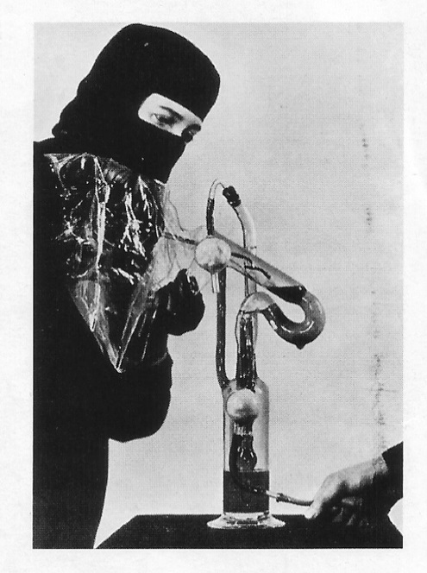
only to keep one isolated organ (a thyroid, for example) supplied with enough blood and oxygen to maintain its vitality. In the second place, Dr. Carrel did not recognize that an anticlotting element is crucial to any artificial organ. Far more damaging to the research, though, was the fact that Dr. Carrel's influence over Charles Lindbergh soon expanded past medical matters, into openly anti-American theories regarding the superiority of Nordic races and the doom of America's mingled nationalities. Within a year or two Lindbergh's public activities in espousing similar views apparently interested him more than any start he had made in medical research, which he set aside for good.
A nurse places a living organ from a human body into the Charles Lindbergh-Alexis Carrel heart pump in the 1930s.
Lindbergh hadn't actually earned any diplomas past high school, but he had been given many honorary degrees as a result of his Atlantic flight, so he was referred to as Dr. Lindbergh in his career at the institute. As preposterous as it seems for a pilot to be masquerading as a medical researcher, the fact is that Lindbergh brought the new field of artificial organs exactly what it needed: practical engineering. If his character did not prove equal to the discipline of medical research, at least he was, as ever, convenient as a symbol: He showed that if medicine and basic engineering were ever to realize the challenge of the artificial replication of an organ, out of reach for either one alone, they must do so as a team.
The first truly productive era in artificial-organ research roughly spanned the 1940s, that most unreal of all decades. At first World War II suspended all hope of progress. Yet before it was over the war also bred technologies that would eventually transform the field's clumsy theories into an astonishing new industry. In the meantime, it was a doctor working in an unlikely fold of the war who
crossed the brink. He built a machine that did the work of a human again.
II: A Breakthrough With Car Parts and Sausage Casing
Willem Kolff was an intern at a teaching hospital in Groningen, Holland, when World War II began in Poland. The following year, while he was on a trip to The Hague to attend a family funeral with
his wife, the German Army crossed the border and took over his country. Most of the conquest of Holland took just five days, but before it was over, Kolff’s department at the hospital was in total disarray. The chairman had committed suicide, along with his wife, because they were Jewish and saw no other way to evade the Nazis.
The administrator who took over the medical department in Groningen was an avowed Nazi, and Kolff refused to answer to him. Instead he transferred to the Municipal Hospital in the quiet old Dutch city of Kampen. After he arrived there in the fall of 1940, he used his spare time to pursue work of his own, that work being, at the time and for the rest of his career, the creation of artificial internal organs. Early in his career Kolff had attended a strapping young farmer dying slowly and painfully of kidney failure. Long before the young man died, someone had to tell his mother, bent by a life of hard work, that there wasn't any hope-that the doctors knew exactly what was wrong but couldn't do anything to stop it. Kolff had that job, and afterward he devoted himself to the far better job of finding a way to replace the function of the kidney.
At the least the invention of artificial organs requires audacity, ingenuity, and desperation, all of which happened to be available in highly pure form in Nazi-occupied Holland. But it also requires sophisticated materials research, and that was so poor in Holland at the time that no start at all could have been made if not for the cooperation of the local Ford auto-repair shop, an enamel-pot manufacturer, and a sausage maker. Conditions in Kampen were hardly ideal. In its isolation, though - out of sight of the Allied nations and cloaked as much as possible from the occupying Germans - Kampen, Holland, in 1944 held even more opportunity than Dr. Kolff knew at the time.
The kidney performs about a half-dozen functions, but the one that becomes a matter of life and death, even in a hospital setting, is the removal of waste and excess water from the bloodstream. People with kidney failure become comatose because they are poisoning themselves as unhealthy substances collect more and more densely in their systems. A healthy kidney would clean it all out through the action of glomeruli: very tiny capillaries, or veins, of which there are about a million in a kidney. The walls of glomeruli are sieves, pocked with holes that are big enough to let molecules of water and waste (known as urea) slip through but too small to let any vital cells or matter out. Over the course of the entire process, some material passes first one way and then the other through the holes, but by the time the blood is on its way out of the kidney, vital chemical balances have been achieved. Blood is forced through the glomeruli under relatively high pressure, to make sure that anything that should be going through the holes will easily do so.
At the teaching hospital in Groningen, Dr. Willem Kolff had learned that cellophane has some of the properties of the walls of a glomerulus, in that it has microscopic holes just the right size to sort blood from waste. At the Municipal Hospital in Kampen, Dr. Kolff built on that piece of knowledge to begin his drive toward a dependable artificial kidney. Two people directly assisted him. One of them was a clinical chemistry technician, A. J. W. van der Ley. The other, J. ("Bob") van Noordwijk, presented problems of his own in that he had been in prison for anti-Nazi activities and was still a wanted man. Disguised in a coal-stoker's uniform, he tinkered with the machine in seclusion during the day, and Dr. Kolff performed experiments with it at night.
First Kolff determined that cellophane was indeed the best material to use in the cleansing, or dialysis, of blood. But working outside official channels, by both necessity and inclination, he had no access to cellophane. The only person who had any was the local sausage maker, so Kolff got him to supply a stock of cellophane sausage casing. It proved to work very well as a substitute for glomeruli.
To induce urea out of the bloodstream, the sausage casing - or membrane, to use the medical term - had to be surrounded by a special solution. Dr. Kolff and Ms. van der Ley began the work of formulating different solutions to act on specific problems in a patient's blood. Kolff meanwhile had to produce movement around the casing to improve the process, since the blood inside it was not under any particular pressure. To exploit centrifugal force to create pressure within the tubing, he used a rotating drum, donated to him by the director of the enamel-pot factory. The tube leading out of the drum had to turn with the overall rotation, but the joint between the two tended to leak. Kolff was stymied for some time until he realized that automobiles are also systems in which liquids must be passed from vessel to vessel without leaks. Upon his request the Kampen Ford dealer provided a water-pump seal that worked out perfectly. Though a kidney is about the size of a fist, each of Kolff's machines was the size of a wardrobe trunk.
Kolff initially tried out his machine on humans at the Municipal Hospital in 1943. In the first sixteen cases the machine worked, but only to improve each patient's condition, not to turn it around. All but one ultimately died of kidney failure, and the one survivor was not saved by the machine. From 1944 to the end of the war in 1945, the Municipal Hospital at Kampen was inundated with war casualties, leaving no time for further trials. After Allied troops had liberated Holland from the Germans, though, a sixty-seven year-old woman dying from
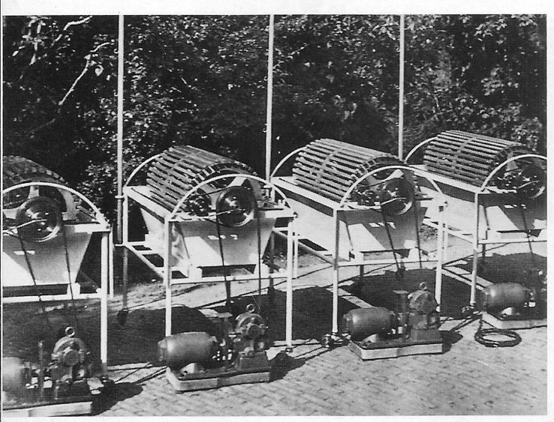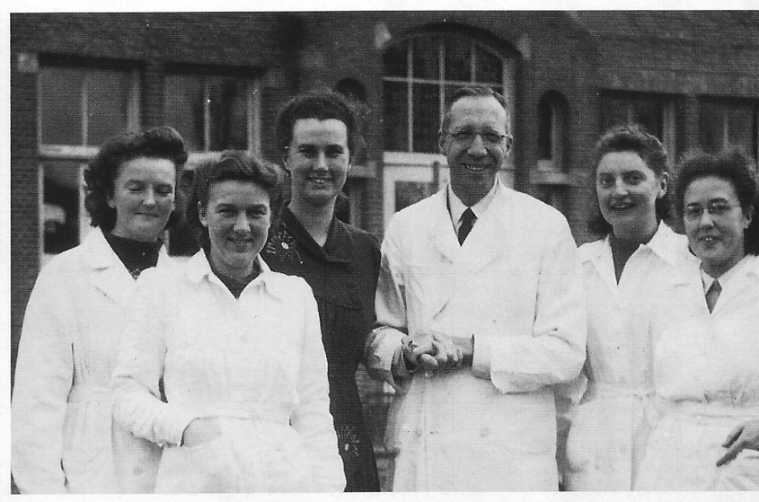
Kolff's four rotating-drum kidneys. await shipment, in Kolff with Kampen lab technicians.
the garden of the hospital in Kampen, shortly after the
war.

kidney failure was brought to the hospital. She would be the seventeenth patient to undergo dialysis by Kolff's machine.
Accused by her own husband of collaboration with the Nazis, the woman had been in prison when she became ill; by the time Dr. Kolff saw her, she was already comatose. Nothing else could possibly save her, so he connected the artificial kidney, bypassing her own. After nearly twelve hours he leaned close to her face and asked if she was able to hear him. The woman opened her eyes, looked at Kolff, and said, "I am going to divorce my husband." Once her own kidneys began to function again, Dr. Kolff disconnected the artificial kidney. With that he had an important success, and Patient No. 17 went on to a normal life-and a divorce.
"After the war," Dr. Kolff later recalled, "I went to see the English information officer in The Hague to inquire whether anything like an artificial kidney had been developed in the free world. It had not." Still, the dominating nations in World War II had gathered scientists into veritable armies of invention that not only changed the ways of war with each week that went by but also left their particular fields littered with new materials, methods, theories, and mechanisms. The war had given rise to a faith that the minds of engineers and scientists, plus money, could equal anything at all. The capacity for overcoming obstacles through engineering made new industries out of aeronautics, physics, plastics, computing, statistics, radiography, and other applied sciences.
Medicine remained somewhat apart until the war ended and doctors around the world learned that Willem Kolff had managed to make an artificial internal organ. Their surprise remained a surprise to Kolff, who presumed that the free world would have surpassed anything possible in an occupied country, but he lost no time in enlisting further help from the enamelware factory in order to build four more of his machines. As soon as they were finished, someone took a snapshot of them, poised on the edge of a moment. "Nephrologists [kidney specialists] are familiar with this picture," wrote Dr. George Schreiner, a pioneer in the field of dialysis, "the four rotating drum artificial kidneys awaiting shipment from the little garden at the hospital at Kampen."
Ill: The Race Is On
Dr. Kolff arranged to send one each of his four kidney machines to London and Montreal, along with assistants to conduct immediate demonstrations. He sent the other two to America, in answer to requests from doctors at Mount Sinai Hospital in New York City and Georgetown University Hospital in Washington. By the time he himself visited America, in 194 7, he had given away all the machines he'd been able to make, but he brought blueprints to distribute. He toured hospitals from Washington to Boston and as far west as Minnesota. Kolff's ideas galvanized practitioners, who copied his design using the latest plastics and alloys and inspired a rising generation of researchers. Optimism ran high. As it happened, Dr. Kolff met five future presidents of the American Society for Artificial Internal Organs on his first tour; each was near the beginning of his career.
Minds and money went to work, and within five years both an improved artificial kidney and a heart-lung machine were in use, the latter opening the way to the remarkable advances in heart surgery of the past thirty-five years. Research into artificial organs, that hybrid of medicine and engineering, had arrived full-born amid the bounty of applied sciences left in place by the waging of World War II. The new philosophy was Willem Kolff's philosophy: Define a function, and then find the materials and the means to replicate it. The new philosophy was that anything was possible.
The U.S. Public Health Service allotted its first grant for research into artificial organs, in 1949, to Dr. John Gibbon at the Jefferson Medical College in Philadelphia, for the development of a heart-lung machine. Gibbon, whose research had been interrupted by his service in the war, also received direct assistance and engineering expertise from International Business Machines. Thomas Watson, the president of IBM, had become personally convinced of the need for an artificial replacement for the heart. So had many other people. In the late 1940s heart disease was by far the leading cause of death in the United States. Four million people had serious heart conditions; six hundred thousand of them died each year. So acute was the need for some way to operate that it was considered a breakthrough when in 1948 a technique was developed for a surgeon to connect a scalpel to the tip of one finger and operate by touch. "For several years," Kolff later said of the period, "they thought there was no use for heart-lung machines and that they could solve every problem with ... blind procedures."
Meanwhile surgeons also made do with harrowingly hurried and limited operations, tying off the blood vessels to drain the heart cavity for about three minutes and performing surgery against the clock. Some did experiments with cross transfusions, letting the heart of a healthy person pump blood for both himself and a patient undergoing corrective surgery. That basic technique had been tried as early as 1492, when Pope Innocent VIII needed an operation and three boys were configured to provide him with oxygenated blood. It hadn't worked then; everybody died, and the surgeon had only barely managed to flee with his own life.
Dr. Gibbon's initial design used two pumps-one to draw blood out of a vein, the other to send it back into an artery-placed on either side of a rotating drum whose constant motion would oxygenate the blood and remove carbon dioxide. IBM's technical contribution lay in replacing the drum. Stationary metal plates incorporating a grid pattern created just enough turbulence to oxygenate the blood but not enough to damage cells, as the drum had done.
Even while Watson was lending Gibbon teams from IBM to work with him on his research, Charles Wilson, chairman of the Michigan State Heart Association and president of General Motors, was hearing a presentation by a Detroit surgeon named Forest Dodrill, who needed help in realizing his ideas for another heart-lung machine. Midway through the meeting, Wilson called in several of GM's research engineers. "We have pumped oil, gasoline, water and other fluids one way or another in our business. It seems only logical we should try to pump blood," said one of them as Wilson committed the GM Research Laboratories to the project.
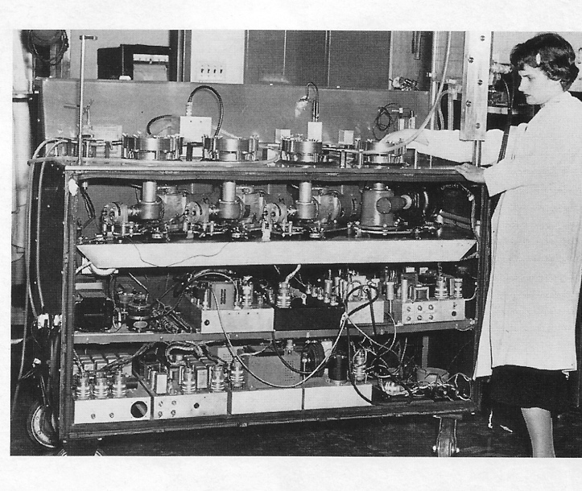
At about the same time, Dr. Clarence Dennis, at the University of Minnesota, began what he later called "a methodical evaluation of a series of configurations" of heart-lung machines. By 1950 other teams at other institutions were in the race - which is what it had become. One was the Cleveland Clinic, where Willem Kolff had been invited to continue his research and where he set up the first department in the world dedicated to the invention of artificial internal organs. Kolff had continued development of the artificial kidney, but he also plunged into research toward a viable heart-lung, or "pump-oxygenator," an interest sparked during a conver-sation with a colleague in Holland three years before, in 1947.
A technician adjusts Dr. Gibbon's six-foot-long machine, early 1950s.
At each of the institutions, dogs, cats, or calves were used for experiments. The number of minutes that one could be sustained on a heart-lung machine became the tally of the race. Dr. Gibbon made headlines in 1949 when one of his cats survived for forty-six minutes. In Michigan a total of eighty-four dogs underwent actual heart operations, beginning to end, and none died. In Minnesota Dr. Dennis had his heart-lung machines sustaining dogs for almost three hours. But it was not four million dogs that suffered heart trouble or six hundred thousand cats that died annually from it. At some point the heart-lung machine was going to have to be tried on a human being.
Someone's lifeblood would have to be trusted to a machine. The question was when, and that is the question that has always haunted innovators in artificial organs. Of all the procedures in medicine, the switchover to an artificial organ is the one with the highest of highs and the lowest of lows. If an artificial organ works, it is an example of the indomitable human spirit overcoming every hurdle; it is a man-made miracle. If it doesn't work, and a patient is hooked up to some contraption with no more hope than before and a lot less dignity or even comfort, then the failure encroaches on morality. It is an unnatural death or, perhaps likewise, a man-made one.
In 1951 a six-year-old girl arrived at the University of Minnesota Hospital with blue skin and irregular breathing. An exploratory operation proved her doctors' suspicions that there was a hole in a wall in her heart. It could have been stitched except for the old problem of access to the heart cavity. A heart-lung machine could be put to use, except that Dr. Dermis's apparatus was configured for use with dogs. There wasn't any other hope for the girl, though, so in a matter of just days the machine was prepared for its first trial with a human. The operation took place, but the girl died after forty minutes from loss of blood. Her malfunctioning heart had already done too much damage to her system to allow her to sustain a major operation under any conditions. Still, the outcome ensured that the other teams trying to develop a heart-lung machine would not rush into anything.
The following year a man arrived at Harper Hospital in Detroit with heart damage left by rheumatic fever. He was forty-one years old and fitted the necessary profile for an experimental case: He was relatively healthy outside of the fact that his heart trouble was degenerating toward a fatal conclusion. The machine developed by GM's team of engineers and Dr. Dodrill's team of doctors was capable of pumping blood, but the lung function was neither ready nor necessary in the case at hand. Surgeons used the artificial heart to pump for the left side of the man's heart, and that allowed them to see the damage and the repair as they made it. For the patient the operation was the beginning of a new life. For the medical world it was no less a beginning. If heart surgery was little but frustration before, it would become a crowning power after 1952.
In May 1953 Dr. Gibbon, in Philadelphia, took on a case that was similar in some ways to that of the little girl in Minnesota: The patient was. a college freshman with a hole the size of a half-dollar in the wall of her heart, between the auricles. She was otherwise strong, however, and for her the ending was happy. She was home within two weeks of open-heart surgery, after having stopped breathing and pumping her own blood for twenty-six minutes while the heart-lung machine kept her alive.
Meanwhile, Dr. Dennis-who had lost a second patient in Minnesota when the technician operating the machine got sick at the sight of an openheart operation and so neglected to turn the right switches-was pursuing his research at a hospital in Brooklyn, New York. There the opportunity for a trial was held up by a series of bureaucratic hitches, one of which seems rather funny in the midst of such a serious subject. Dennis was told that his heart-lung machine was "insufficiently professional in appearance" to be seen in an operating room. It was a question of bodywork, so the surgeon brought in a German metalworker to recast the apparatus in gleaming stainless steel. As it turned out, Dermis's design came to play an integral role in the improvement of the heart-lung machine, even though it was not the first. Other successful designs were developed by Marquardt, an aerospace company in Los Angeles, and Willem Kolff's group in Cleveland, as the heart-lung machine was refined into regular use for open-heart surgery by 1955.

IV: The Final Frustrations
The artificial kidney and the heart-lung machine dramatically changed the treatment options for some
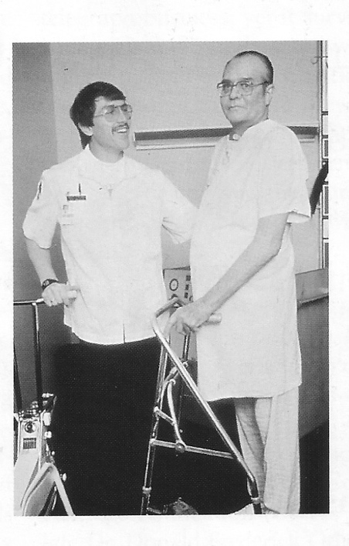
very common diseases. In their wake artificialorgan research naturally expanded as doctors teamed with engineers in centers all over America. The ultimate goal was to make a whole organ; when that seemed to be out of reach, researchers replicated at least one function, making partial organs, or assist devices, as they are sometimes called. The goal was also to make an implantable organ, one that would allow a patient to live a normal life. In December 1957 Kolff's team in Cleveland replaced a dog's heart with an implantable artificial heart driven by an air pump; the dog lived for an hour and a half, and the future boded well for the development of an artificial heart for humans. The factors left to be addressed did not seem insurmountable: The material had to be flexible, durable, and compatible with real tissue, and the power source had to be reliable and unobtrusive. The implant itself had to be a pump small enough to fit in the body and powerful enough to maintain the exact right flow of blood. The problems were simple to explain. They did not prove simple to solve.
Barney Clark (right) works with a physical therapist in 1983 after receiving the first implanted artificial heart.
In 1967 Kolff founded the Institute for Biomedical Engineering at the University of Utah, in Salt Lake City, with which he has been associated ever since. Research there has advanced artificial sight, hearing, and limbs. A breakthrough called the Wearable Artificial Kidney, developed at the institute in the mid-1970s, allows patients to be nearly as mobile as they would be with an implantable version of the organ. "Being the director of a multidisciplinary Institute for Biomedical Engineering is a most delightful experience," Kolff said in 1972. "Many of us meet at 8:00 every morning. Chemists, polymer scientists, physicists, electrical, mechanical, industrial and nuclear engineers, kidney doctors, heart surgeons, an anesthesiologist, a veterinarian, a metallurgist, a modelshop machinist, and people able to make artificial hearts out of Silastic (silicone rubber}-they all come together at 8:00, meet for thirty minutes and then go out to their various buildings and their various disciplines. The future for artificial organs is unlimited."
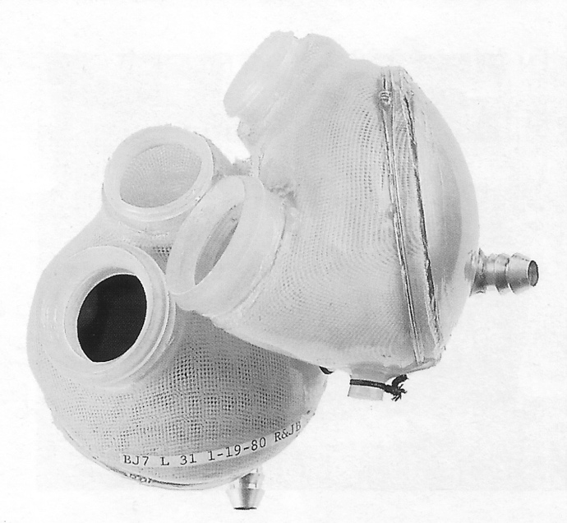
In 1982, KOLFF and a colleague, Robert Jarvik, made the first artificial heart ever implanted in a human patient, Dr. Barney Clark. He lived with it for 112 days. The heart, called the Jarvik-7, was capable enough in its immediate function, but it never produced wholly satisfactory results. Implantable hearts developed around the world are used only sporadically today, usually as a so-called bridge, for people awaiting transplantation of a human heart. The heart would seem to be the simplest of all organs mechanically. It is a pump. Yet, after thirty years of terrific effort, the attempt to make one is still just a long and complex latest stage in the pursuit of artificial organs.
Robert Jarvik's Jarvik-7 heart was the kind implanted in Barney Clark, who lived with it for 112 days. The device never produced wholly satisfactory results.

Willem Kolff, widely honored as the father of artificial organs, is still working at his lab every day, surrounded by modern equipment and materials, probably the finest that money can buy. It is a long way from Kampen, where he laid the field's groundwork even while hiding assistants and begging parts, but he maintains the determination he showed then. "At this time," he told a conference in 1994, "when 33,000 people die for lack of an artificial heart in the United States each year, I would like to propose that you give me 1,000 patients who are going to die within a few days. I could give these patients the best artificial hearts I can make and assume that 2 percent of the hearts would break. If that was the case, I would lose 20 patients from broken hearts. Altogether, 120 patients would die, but I would save 880 patients. Please compare that with the attitudes of the National Institutes of Health and the Food and Drug Administration. They do not want to apply an artificial heart until they think it is perfect."
Willem Kolff's career spans the history of artificial-organ development. At the Municipal Hospital in Kampen, he cultivated a humane sense that desperate resolve is the equal of any problem, that it is, in fact, the only attitude to have toward disease. That attitude has brought Dr. Kolff heroic triumphs in fifty years, but it places him and the field that he launched still at the start, with enormous challenges ahead.

